|  |
| --- |
|  |
| Web Designing Experiments |
|  |
|  |
| **Vansh Sukhija**  **12112021** |
|  |

|  |
| --- |
|  |

Experiment 1-

<!DOCTYPE html>

<html lang="en">

<head>

    <meta charset="UTF-8">

    <meta http-equiv="X-UA-Compatible" content="IE=edge">

    <meta name="viewport" content="width=device-width, initial-scale=1.0">

    <title>Experiment 1</title>

</head>

<body style="background-color: rgb(235, 255, 255);">

    <h1 style="text-align: center; color: darkcyan;" id="top">Computer Engineering</h1>

    <p>

        <ul>

            <li>

                The department started offering B.Tech. Programme in Computer Engineering in 1987 with initial intake of 30 students and subsequently raised to 92. Department also started B.Tech programme in Information Technology (IT) in 2006 with present intake of 92 students. The department is proud to have a record of almost 100% placement for last 10 years. The department also offers two M.Tech. programs, one in Computer Engineering and other in Cyber Security. Department started Ph.D. program in 2002. So far 44 Ph.D.s have been awarded and 28 PhDs are in progress. Currently there are five sponsored projects undergoing in the department.<br><br>

            </li>

            <li>

                Faculty of the department have specialized areas for advanced studies and research in Distributed Computing, Software Engineering, Computer Networks, Database and Data Mining, Natural Language Processing, Information and Cyber Security, Image Processing.<br><br>

            </li>

            <li>

                The department is well equipped with state-of-the-art laboratories of all major domains of Computer Engineering and Information Technology with excellent intranet, servers, hardware and software support.<br><br>

            </li>

            <li>

                Each year, many students of the department get selected for higher studies in world's most reputed Universities and Institutes. The department is equally active in research with many quality publications each year in IEEE, Sciencedirect, ACM, Springer, Wiley etc. For the overall development we also cover the other aspects of life like Health management, moral and ethical development of the students.<br><br>

            </li>

        </ul>

    </p>

    <h2 style="color: darkcyan;">Useful Links</h2>

    <p>

        <a href="https://en.wikipedia.org/wiki/Wi-Fi">Click here</a> to know about Wi-Fi.<br>

        <a href="https://en.wikipedia.org/wiki/Lan">Click here</a> to know about LAN.<br>

    </p>

    <h2 style="color: darkcyan;">Inserting Image</h2>

    <a href="https://www.google.com/url?sa=i&url=https%3A%2F%2Fen.wikipedia.org%2Fwiki%2FNational_Institute_of_Technology%2C_Kurukshetra&psig=AOvVaw1BPW_3-VaF91b0hXMbj4EB&ust=1650432057445000&source=images&cd=vfe&ved=0CA4Q3YkBahcKEwjQxaPlsJ_3AhUAAAAAHQAAAAAQAw" target="_">

        <img src="https://upload.wikimedia.org/wikipedia/en/7/75/National_Institute_of_Technology%2C_Kurukshetra_Logo.png" alt="NIT Kurukshetra">

    </a><br><br>

    <a href="#top">Go to top</a>

</body>

</html>

Output-



Formatting tags-

<!DOCTYPE html>

<html lang="en">

<head>

    <meta charset="UTF-8">

    <meta http-equiv="X-UA-Compatible" content="IE=edge">

    <meta name="viewport" content="width=device-width, initial-scale=1.0">

    <title>Formatting Tags</title>

</head>

<body>

    <b>this is bold</b><br>

    <strong>this is strong</strong><br>

    <i>this is italic</i><br>

    <em>this is em</em><br>

    <span>this is span</span><br>

    <div>this is div</div>

    <marquee direction="left">this is marquee</marquee><br>

    <strike>this is strike</strike><br>

    <del>this is del</del><br>

    <u>this is underline</u><br>

    <ins>this is ins</ins><br>

    abcd<sub>this is subscript</sub><br>

    abcd<sup>this is superscript</sup><br>

    <q>this is quotation</q><br>

    <big>this is big</big><br>

    <small>this is small</small><br>

    <a href="about.html" target="main"><img src="My Site/images/pfp.jpg" alt="profile-picture" style="width: 15%;"></a><br>

    <iframe width="560" height="315" src="https://www.youtube.com/embed/MSaTHqSe7Pk" title="YouTube video player" frameborder="0" allow="accelerometer; autoplay; clipboard-write; encrypted-media; gyroscope; picture-in-picture" allowfullscreen></iframe>

</body>

</html>

Output-

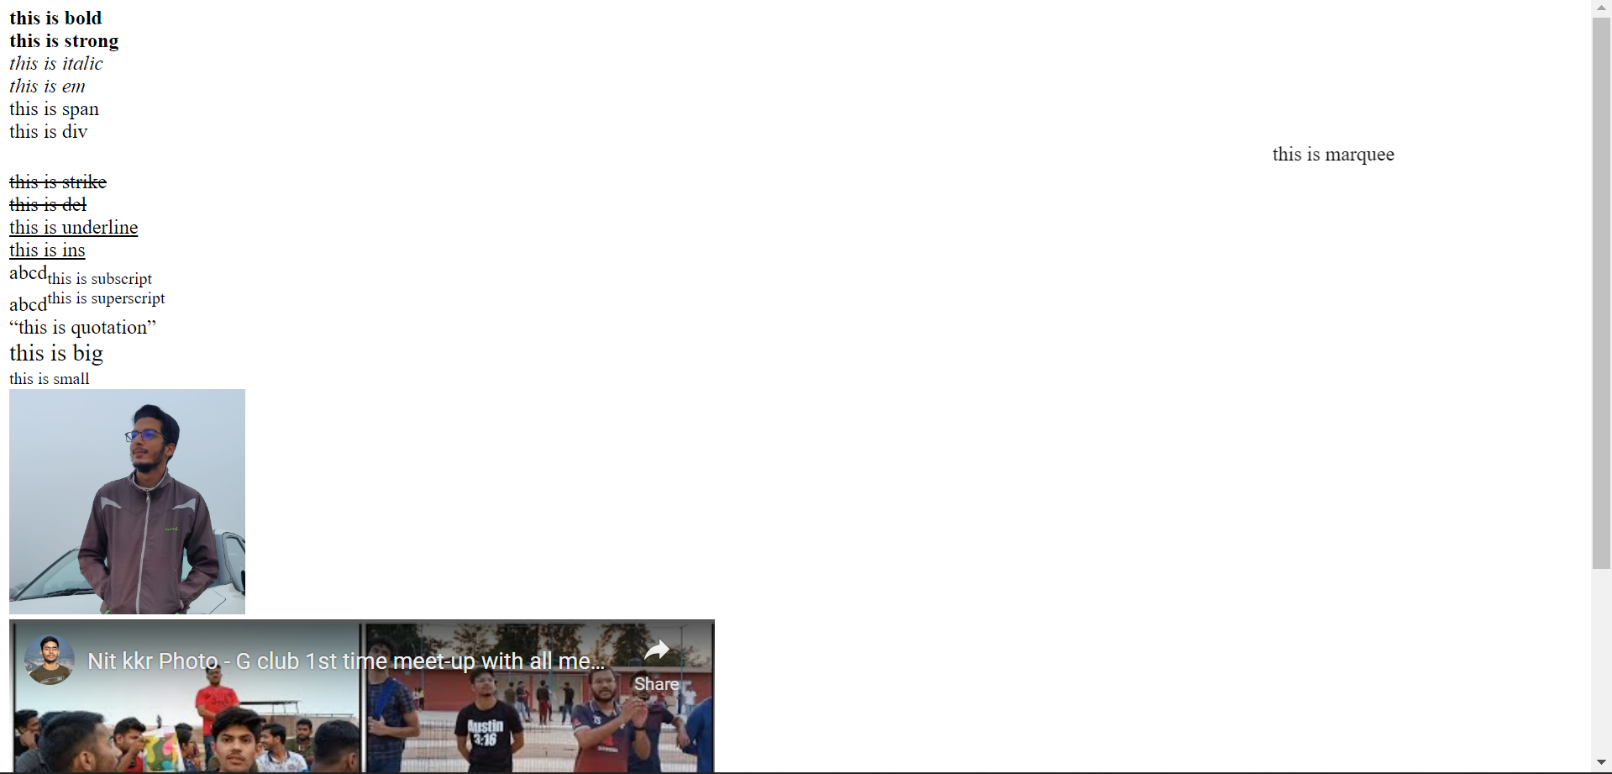

Experiment 2-

<!DOCTYPE html>

<html lang="en">

<head>

     <meta charset="UTF-8">

     <meta http-equiv="X-UA-Compatible" content="IE=edge">

     <meta name="viewport" content="width=device-width, initial-scale=1.0">

     <title>Experiment-2</title>

     <style>

          .days {

*background-color*: blanchedalmond;

          }

          .infra{

*background-color*:rgb(0, 211, 211);

          }

     </style>

</head>

<body>

     <div style="text-align: center;">

          <h1>CS Time-Table</h1>

     </div>

     <table width="90%" border="2" style="text-align: center; margin-left: 5%;">

          <thead class="days">

               <tr>

                    <th colspan="12">MONDAY</th>

               </tr>

          </thead>

          <tbody>

               <tr>

                    <th></th>

                    <th></th>

                    <th>1</th>

                    <th>2</th>

                    <th>3</th>

                    <th>4</th>

                    <th>5</th>

                    <th>6</th>

                    <th>7</th>

                    <th>8</th>

                    <th>9</th>

                    <th>10</th>

               </tr>

               <tr>

                    <td rowspan="4">CS-A</td>

                    <td>1</td>

                    <td rowspan="4">MA-L</td>

                    <td rowspan="4">DC3-L</td>

                    <td rowspan="2" colspan="2">DC2-P</td>

                    <td></td>

                    <td rowspan="4">CH-L</td>

                    <td rowspan="2" colspan="2">DC3-P</td>

                    <td></td>

                    <td></td>

               </tr>

               <tr>

                    <td>2</td>

                    <td></td>

                    <td></td>

                    <td></td>

               </tr>

               <tr>

                    <td>3</td>

                    <td colspan="2" rowspan="2">DC3-P</td>

                    <td></td>

                    <td>EE-T</td>

                    <td></td>

                    <td>DC-T</td>

                    <td>PH-T</td>

               </tr>

               <tr>

                    <td>4</td>

                    <td></td>

                    <td>DC-T</td>

                    <td></td>

                    <td>EE-T</td>

                    <td>CH-T</td>

               </tr>

          </tbody>

          <thead class="days">

               <tr>

                    <th colspan="12">TUESDAY</th>

               </tr>

          </thead>

          <tbody>

               <tr>

                    <th></th>

                    <th></th>

                    <th>1</th>

                    <th>2</th>

                    <th>3</th>

                    <th>4</th>

                    <th>5</th>

                    <th>6</th>

                    <th>7</th>

                    <th>8</th>

                    <th>9</th>

                    <th>10</th>

               </tr>

               <tr>

                    <td rowspan="4">CS-A</td>

                    <td>1</td>

                    <td rowspan="4" colspan="3">WD-P</td>

                    <td></td>

                    <td rowspan="4">DC3-L</td>

                    <td></td>

                    <td rowspan="4">DC1-L</td>

                    <td rowspan="4">DC2-L</td>

                    <td>EE-T</td>

                    <td>CH-T</td>

               </tr>

               <tr>

                    <td>2</td>

                    <td></td>

                    <td></td>

                    <td>PH-T</td>

                    <td>EE-T</td>

               </tr>

               <tr>

                    <td>3</td>

                    <td></td>

                    <td></td>

                    <td>CH-T</td>

                    <td>MA-T</td>

               </tr>

               <tr>

                    <td>4</td>

                    <td></td>

                    <td></td>

                    <td>MA-T</td>

                    <td>PH-T</td>

               </tr>

          </tbody>

          <thead class="days">

               <tr>

                    <th colspan="12">WEDNESDAY</th>

               </tr>

          </thead>

          <tbody>

               <tr>

                    <th></th>

                    <th></th>

                    <th>1</th>

                    <th>2</th>

                    <th>3</th>

                    <th>4</th>

                    <th>5</th>

                    <th>6</th>

                    <th>7</th>

                    <th>8</th>

                    <th>9</th>

                    <th>10</th>

               </tr>

               <tr>

                    <td rowspan="4">CS-A</td>

                    <td>1</td>

                    <td rowspan="4" colspan="2">PH-P</td>

                    <td rowspan="4">PH-L</td>

                    <td rowspan="4">EE-L</td>

                    <td></td>

                    <td rowspan="4">MA-L</td>

                    <td></td>

                    <td></td>

                    <td>MA-T</td>

                    <td></td>

               </tr>

               <tr>

                    <td>2</td>

                    <td></td>

                    <td></td>

                    <td></td>

                    <td>DC-T</td>

                    <td>CH-T</td>

               </tr>

               <tr>

                    <td>3</td>

                    <td></td>

                    <td rowspan="2" colspan="2">DC2-P</td>

                    <td></td>

                    <td></td>

               </tr>

               <tr>

                    <td>4</td>

                    <td></td>

                    <td></td>

                    <td></td>

               </tr>

          </tbody>

          <thead class="days">

               <tr>

                    <th colspan="12">THURSDAY</th>

               </tr>

          </thead>

          <tbody>

               <tr>

                    <th></th>

                    <th></th>

                    <th>1</th>

                    <th>2</th>

                    <th>3</th>

                    <th>4</th>

                    <th>5</th>

                    <th>6</th>

                    <th>7</th>

                    <th>8</th>

                    <th>9</th>

                    <th>10</th>

               </tr>

               <tr>

                    <td rowspan="4">CS-A</td>

                    <td>1</td>

                    <td>DC-T</td>

                    <td>PH-T</td>

                    <td rowspan="4">DC3-L</td>

                    <td rowspan="4">DC1-L</td>

                    <td rowspan="4">EE-L</td>

                    <td></td>

                    <td rowspan="4">DC2-L</td>

                    <td rowspan="4">MA-L</td>

                    <td></td>

                    <td></td>

               </tr>

               <tr>

                    <td>2</td>

                    <td></td>

                    <td></td>

                    <td></td>

                    <td>MA-T</td>

                    <td></td>

               </tr>

               <tr>

                    <td>3</td>

                    <td></td>

                    <td></td>

                    <td></td>

                    <td></td>

                    <td></td>

               </tr>

               <tr>

                    <td>4</td>

                    <td></td>

                    <td></td>

                    <td></td>

                    <td></td>

                    <td></td>

               </tr>

          </tbody>

          <thead class="days">

               <tr>

                    <th colspan="12">FRIDAY</th>

               </tr>

          </thead>

          <tbody>

               <tr>

                    <th></th>

                    <th></th>

                    <th>1</th>

                    <th>2</th>

                    <th>3</th>

                    <th>4</th>

                    <th>5</th>

                    <th>6</th>

                    <th>7</th>

                    <th>8</th>

                    <th>9</th>

                    <th>10</th>

               </tr>

               <tr>

                    <td rowspan="4">CS-A</td>

                    <td>1</td>

                    <td rowspan="4">DC2-L</td>

                    <td rowspan="4">CH-L</td>

                    <td rowspan="4">DC1-L</td>

                    <td rowspan="4">WD-L</td>

                    <td rowspan="4">PH-L</td>

                    <td></td>

                    <td rowspan="4" colspan="2">CH-P</td>

                    <td></td>

                    <td></td>

               </tr>

               <tr>

                    <td>2</td>

                    <td></td>

                    <td></td>

                    <td></td>

               </tr>

               <tr>

                    <td>3</td>

                    <td></td>

                    <td></td>

                    <td></td>

               </tr>

               <tr>

                    <td>4</td>

                    <td></td>

                    <td></td>

                    <td></td>

               </tr>

          </tbody>

          <thead class="days">

               <tr>

                    <th colspan="12">SATURDAY</th>

               </tr>

          </thead>

          <tbody>

               <tr>

                    <th></th>

                    <th></th>

                    <th>1</th>

                    <th>2</th>

                    <th>3</th>

                    <th>4</th>

                    <th>5</th>

                    <th>6</th>

                    <th>7</th>

                    <th>8</th>

                    <th>9</th>

                    <th>10</th>

               </tr>

               <tr>

                    <td rowspan="4">CS-A</td>

                    <td>1</td>

                    <td rowspan="4">WD-L</td>

                    <td rowspan="4">EE-L</td>

                    <td rowspan="4">MA-L</td>

                    <td rowspan="4">DC1-L</td>

                    <td rowspan="4">DC2-L</td>

                    <td></td>

                    <td rowspan="4">DC3-L</td>

                    <td rowspan="4">CH-L</td>

                    <td rowspan="4">PH-L</td>

                    <td></td>

               </tr>

               <tr>

                    <td>2</td>

                    <td></td>

                    <td></td>

               </tr>

               <tr>

                    <td>3</td>

                    <td></td>

                    <td></td>

               </tr>

               <tr>

                    <td>4</td>

                    <td></td>

                    <td></td>

               </tr>

          </tbody>

     </table>

     <hr>

     <div>

          <table width="80%" border="2" style="margin-left: 10%; text-align: center; font-size: larger;">

               <caption style="font-size: large;">DETAILS OF INFRASTRUCTURE</caption><br>

               <thead class="infra">

                    <tr>

                         <th>S.No.</th>

                         <th>Details</th>

                         <th>Area (in sqm)</th>

                    </tr>

               </thead>

               <tbody>

                    <tr>

                         <td>1.</td>

                         <td>NIT Main Gates<br>Along Kirmich road<br>towards KUK</td>

                         <td>31.14</td>

                    </tr>

                    <tr>

                         <td>2.</td>

                         <td>Creche</td>

                         <td>854.12</td>

                    </tr>

               </tbody>

          </table>

          <br><br><br>

          <table width="80%" border="2" style="margin-left: 10%; text-align: center; font-size: larger;">

               <caption style="font-size: large;">ACADEMIC AREA</caption><br>

               <thead class="infra">

                    <tr>

                         <th>S.No.</th>

                         <th>Details</th>

                         <th>Area (in sqm)</th>

                    </tr>

               </thead>

               <tbody>

                    <tr>

                         <td>1.</td>

                         <td>Office Space: <br>

                              Golden Jubilee Administrative Building <br>

                              Old Admn. Block <br>

                              Estate Store

                         </td>

                         <td>4,552 <br>

                              6,261.92 <br>

                              1156.08

                         </td>

                    </tr>

                    <tr>

                         <td>2.</td>

                         <td>Electrical Block</td>

                         <td>5363.99</td>

                    </tr>

                    <tr>

                         <td>3.</td>

                         <td>Mechanical Deptt.</td>

                         <td>1545.27</td>

                    </tr>

                    <tr>

                         <td>4.</td>

                         <td>Civil Engg. Deptt.</td>

                         <td>1558.73</td>

                    </tr>

                    <tr>

                         <td>5.</td>

                         <td>AM Block</td>

                         <td>1805.41</td>

                    </tr>

                    <tr>

                         <td>6.</td>

                         <td>AB block/ ED cell</td>

                         <td>1245.42</td>

                    </tr>

                    <tr>

                         <td>7.</td>

                         <td>Workshop Equip. Bldg./ Old MBA&MCA & Class rooms at Ist Floor</td>

                         <td>5155.11</td>

                    </tr>

                    <tr>

                         <td>8.</td>

                         <td>MBA & MCA Deptt.</td>

                         <td>3503.66</td>

                    </tr>

                    <tr>

                         <td>9.</td>

                         <td>12 No. Lecture Theatre Complex</td>

                         <td>3298.24</td>

                    </tr>

                    <tr>

                         <td>10.</td>

                         <td>Electronics & Comm. Engg. Deptt.</td>

                         <td>1809.32</td>

                    </tr>

                    <tr>

                         <td>11.</td>

                         <td>06 No. Lecture Theatre Complex</td>

                         <td>1239.68</td>

                    </tr>

                    <tr>

                         <td>12.</td>

                         <td>Computer Engg. Deptt.</td>

                         <td>2104.51</td>

                    </tr>

                    <tr>

                         <td>13.</td>

                         <td>Mechanical Engg. Block</td>

                         <td>6240.00</td>

                    </tr>

                    <tr>

                         <td>14.</td>

                         <td>Work shop Complex Part-1</td>

                         <td>4145.20</td>

                    </tr>

                    <tr>

                         <td>15.</td>

                         <td>Examination Hall</td>

                         <td>1878.81</td>

                    </tr>

               </tbody>

          </table>

     </div>

     <div style="margin-left: 5%; margin-top: 5%; width: 90%; text-align: center; border-style: outset; border-radius: 9px;">

          <h3>The Good'ol RickRoll</h3>

          <div style="margin-left: auto; padding-bottom: 25px; height: 45vh;">

               <iframe width="70%" height="100%" src="https://www.youtube.com/embed/dQw4w9WgXcQ" title="YouTube video player" frameborder="0"

                    allow="accelerometer; autoplay; clipboard-write; encrypted-media; gyroscope; picture-in-picture"

                    allowfullscreen></iframe><br>

               <audio controls style="margin-top: 5%;">

                    <source src="y.mp3" type="audio/mpeg">

                    Your browser does not support the audio element.

               </audio>

          </div>

     </div>

</body>

</html>

Output-

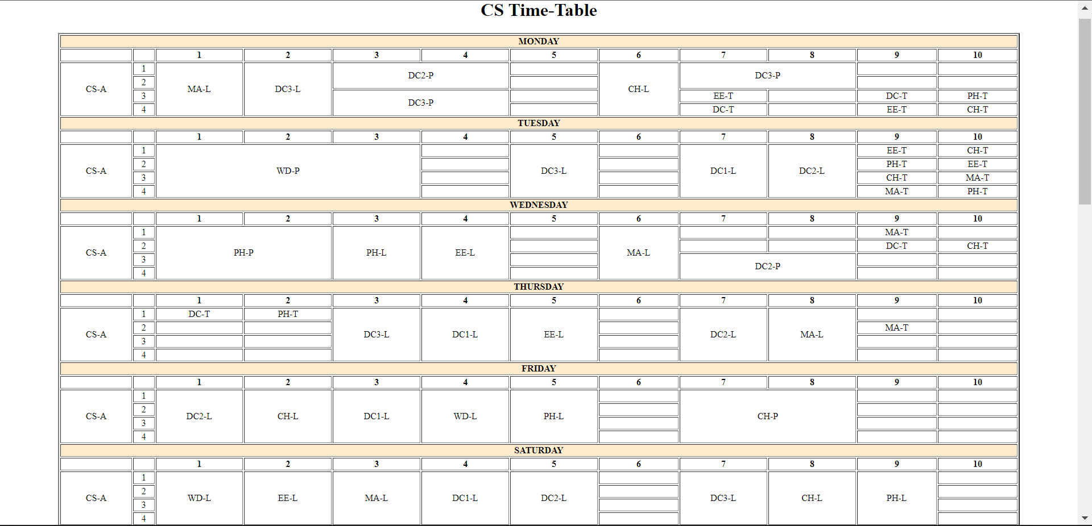

Frames 1-

<!DOCTYPE html>

<html lang="en">

<head>

    <meta charset="UTF-8">

    <meta http-equiv="X-UA-Compatible" content="IE=edge">

    <meta name="viewport" content="width=device-width, initial-scale=1.0">

    <title>Frames1</title>

</head>

<body style="background-color: rgb(222, 245, 220);">

    <h2>HTML Reference</h2>

    <a target="_blank" style="text-decoration: none; color: black;" href="https://www.w3schools.com/tags/default.asp">HTML by Alphabet</a><br><br>

    <a target="_blank" style="text-decoration: none; color: black;" href="https://www.w3schools.com/tags/ref_byfunc.asp">HTML by Category</a><br><br>

    <a target="_blank" style="text-decoration: none; color: black;" href="https://www.w3schools.com/tags/ref_html_browsersupport.asp">HTML Browser Support</a><br><br>

    <a target="_blank" style="text-decoration: none; color: black;" href="https://www.w3schools.com/tags/ref_attributes.asp">HTML Attributes</a><br><br>

    <a target="_blank" style="text-decoration: none; color: black;" href="https://www.w3schools.com/tags/ref_standardattributes.asp">HTML Global Attributes</a><br><br>

    <a target="_blank" style="text-decoration: none; color: black;" href="https://www.w3schools.com/tags/ref_eventattributes.asp">HTML Events</a><br><br>

    <a target="_blank" style="text-decoration: none; color: black;" href="https://www.w3schools.com/tags/ref_colornames.asp">HTML Colors</a><br><br>

    <a target="_blank" style="text-decoration: none; color: black;" href="https://www.w3schools.com/tags/ref_canvas.asp">HTML Canvas</a><br><br>

    <a target="_blank" style="text-decoration: none; color: black;" href="https://www.w3schools.com/tags/ref_av_dom.asp">HTML Audio/Video</a><br><br>

    <a target="_blank" style="text-decoration: none; color: black;" href="https://www.w3schools.com/tags/ref_charactersets.asp">HTML Charactersets</a><br><br>

    <a target="_blank" style="text-decoration: none; color: black;" href="https://www.w3schools.com/tags/ref_html_dtd.asp">HTML Doctypes</a><br><br>

    <a target="_blank" style="text-decoration: none; color: black;" href="https://www.w3schools.com/tags/ref_urlencode.asp">HTML URL Encode</a><br><br>

    <a target="_blank" style="text-decoration: none; color: black;" href="https://www.w3schools.com/tags/ref_language_codes.asp">HTML Language Codes</a><br><br>

    <a target="_blank" style="text-decoration: none; color: black;" href="https://www.w3schools.com/tags/ref_country_codes.asp">HTML Country Codes</a><br><br>

    <h2>HTML Tags</h2>

    <a target="_blank" style="text-decoration: none; color: black;" href="https://www.w3schools.com/tags/tag_doctype.asp">< !DOCTYPE ></a><br><br>

    <a target="_blank" style="text-decoration: none; color: black;" href="https://www.w3schools.com/tags/tag_audio.asp">< audio ></a><br><br>

    <a target="_blank" style="text-decoration: none; color: black;" href="https://www.w3schools.com/tags/tag_blockquote.asp">< blockquote ></a><br><br>

    <a target="_blank" style="text-decoration: none; color: black;" href="https://www.w3schools.com/tags/tag_caption.asp">< caption ></a><br><br>

    <a target="_blank" style="text-decoration: none; color: black;" href="https://www.w3schools.com/tags/tag_div.asp">< div ></a><br><br>

    <a target="_blank" style="text-decoration: none; color: black;" href="https://www.w3schools.com/tags/tag_embed.asp">< embed ></a><br><br>

    <a target="_blank" style="text-decoration: none; color: black;" href="https://www.w3schools.com/tags/tag_form.asp">< form ></a><br><br>

    <a target="_blank" style="text-decoration: none; color: black;" href="https://www.w3schools.com/tags/tag_header.asp">< header ></a><br><br>

    <a target="_blank" style="text-decoration: none; color: black;" href="https://www.w3schools.com/tags/tag_img.asp">< img ></a><br><br>

    <a target="_blank" style="text-decoration: none; color: black;" href="https://www.w3schools.com/tags/tag_label.asp">< label ></a><br><br>

    <a target="_blank" style="text-decoration: none; color: black;" href="https://www.w3schools.com/tags/tag_meta.asp">< meta ></a><br><br>

</body>

</html>

Frames 2-

<!DOCTYPE html>

<html lang="en">

<head>

    <meta charset="UTF-8">

    <meta http-equiv="X-UA-Compatible" content="IE=edge">

    <meta name="viewport" content="width=device-width, initial-scale=1.0">

    <title>Frames 2</title>

    <style>

        body{

*background-color*: rgb(222, 245, 220);

        }

        a{

*text-decoration*: none;

*color*: black;

        }

    </style>

</head>

<body>

    <h2>Most popular in HTML</h2>

    <a href="https://www.geeksforgeeks.org/how-to-update-node-js-and-npm-to-next-version/?ref=leftbar-rightbar">How to update Node.js and NPM to next version?</a><br><br>

    <a href="https://www.geeksforgeeks.org/top-10-projects-for-beginners-to-practice-html-and-css-skills/?ref=leftbar-rightbar">Top 10 projects for beginners to practice HTML and CSS skills</a><br><br>

    <a href="https://www.geeksforgeeks.org/how-to-insert-spaces-tabs-in-text-using-html-css/?ref=leftbar-rightbar">How to insert spaces/tabs in text using HTML/CSS?</a><br><br>

    <a href="https://www.geeksforgeeks.org/how-to-set-the-default-value-for-an-html-select-element/?ref=leftbar-rightbar">How to set default value for an HTML < select > element?</a><br><br>

    <a href="https://www.geeksforgeeks.org/hide-or-show-elements-in-html-using-display-property/?ref=leftbar-rightbar">Hide or show elements in HTML using display property</a><br><br>

    <div style="height: 100px;"></div>

    <h2>More Related Articles in HTML</h2>

    <a href="https://www.geeksforgeeks.org/how-to-set-input-type-date-in-dd-mm-yyyy-format-using-html/?ref=leftbar-rightbar">How to set input type date in dd-mm-yyyy format using HTML?</a><br><br>

    <a href="https://www.geeksforgeeks.org/rest-api-introduction/?ref=leftbar-rightbar">REST API (Introduction)</a><br><br>

    <a href="https://www.geeksforgeeks.org/types-of-css-cascading-style-sheet/?ref=leftbar-rightbar">Types of CSS (Cascading Style Sheet)</a><br><br>

    <a href="https://www.geeksforgeeks.org/css-to-put-icon-inside-an-input-element-in-a-form/?ref=leftbar-rightbar">CSS to put icon inside an input element in a form</a><br><br>

    <a href="https://www.geeksforgeeks.org/how-to-insert-form-data-into-database-using-php/?ref=leftbar-rightbar">How to Insert Form Data into Database using PHP?</a><br><br>

</body>

</html>

Frames 3-

<!DOCTYPE html>

<html lang="en">

<head>

    <meta charset="UTF-8">

    <meta http-equiv="X-UA-Compatible" content="IE=edge">

    <meta name="viewport" content="width=device-width, initial-scale=1.0">

    <title>Frames 3</title>

    <style>

        img{

*float*: right;

*width*: 170px;

*margin*: 2%;

        }

    </style>

</head>

<body>

    <h1>HTML</h1>

    <hr>

    <small>From Wikipedia, the free encyclopedia</small>

    <p>

        The Hyper Text Markup Language or HTML is the standard markup language for documents designed to be displayed in

        a web browser. It can be assisted by technologies such as Cascading Style Sheets (CSS) and scripting languages

        such as JavaScript. <br><br>

        <img src="180px-HTML5_logo_and_wordmark.svg.png" alt="html">

        Web browsers receive HTML documents from a web server or from local storage and render the documents into

        multimedia web pages. HTML describes the structure of a web page semantically and originally included cues for

        the appearance of the document. <br><br>

        HTML elements are the building blocks of HTML pages. With HTML constructs, images and other objects such as

        interactive forms may be embedded into the rendered page. HTML provides a means to create structured documents

        by denoting structural semantics for text such as headings, paragraphs, lists, links, quotes and other items.

        HTML elements are delineated by tags, written using angle brackets. Tags such as img and input directly

        introduce content into the page. Other tags such as p surround and provide information about document text and

        may include other tags as sub-elements. Browsers do not display the HTML tags but use them to interpret the

        content of the page. <br><br>

        HTML can embed programs written in a scripting language such as JavaScript, which affects the behavior and

        content of web pages. Inclusion of CSS defines the look and layout of content. The World Wide Web Consortium

        (W3C), former maintainer of the HTML and current maintainer of the CSS standards, has encouraged the use of CSS

        over explicit presentational HTML since 1997. A form of HTML, known as HTML5, is used to display video and

        audio, primarily using the canvas element, in collaboration with javascript. <br><br>

    </p>

    <h2>History</h2>

    <hr>

    <p>

        In 1980, physicist Tim Berners-Lee, a contractor at CERN, proposed and prototyped ENQUIRE, a system for CERN researchers to use and share documents. In 1989, Berners-Lee wrote a memo proposing an Internet-based hypertext system. Berners-Lee specified HTML and wrote the browser and server software in late 1990. That year, Berners-Lee and CERN data systems engineer Robert Cailliau collaborated on a joint request for funding, but the project was not formally adopted by CERN. In his personal notes from 1990 he listed "some of the many areas in which hypertext is used" and put an encyclopedia first. <br><br>

        <img src="255px-Tim_Berners-Lee_April_2009.jpg" alt="TimBernersLee"><br>

        The first publicly available description of HTML was a document called "HTML Tags", first mentioned on the Internet by Tim Berners-Lee in late 1991. It describes 18 elements comprising the initial, relatively simple design of HTML. Except for the hyperlink tag, these were strongly influenced by SGMLguid, an in-house Standard Generalized Markup Language (SGML)-based documentation format at CERN. Eleven of these elements still exist in HTML 4. <br><br>

        HTML is a markup language that web browsers use to interpret and compose text, images, and other material into visual or audible web pages. Default characteristics for every item of HTML markup are defined in the browser, and these characteristics can be altered or enhanced by the web page designer's additional use of CSS. Many of the text elements are found in the 1988 ISO technical report TR 9537 Techniques for using SGML, which in turn covers the features of early text formatting languages such as that used by the RUNOFF command developed in the early 1960s for the CTSS (Compatible Time-Sharing System) operating system: these formatting commands were derived from the commands used by typesetters to manually format documents. However, the SGML concept of generalized markup is based on elements (nested annotated ranges with attributes) rather than merely print effects, with also the separation of structure and markup; HTML has been progressively moved in this direction with CSS. <br><br>

        Berners-Lee considered HTML to be an application of SGML. It was formally defined as such by the Internet Engineering Task Force (IETF) with the mid-1993 publication of the first proposal for an HTML specification, the "Hypertext Markup Language (HTML)" Internet Draft by Berners-Lee and Dan Connolly, which included an SGML Document type definition to define the grammar. The draft expired after six months, but was notable for its acknowledgment of the NCSA Mosaic browser's custom tag for embedding in-line images, reflecting the IETF's philosophy of basing standards on successful prototypes. Similarly, Dave Raggett's competing Internet-Draft, "HTML+ (Hypertext Markup Format)", from late 1993, suggested standardizing already-implemented features like tables and fill-out forms. <br><br>

        After the HTML and HTML+ drafts expired in early 1994, the IETF created an HTML Working Group, which in 1995 completed "HTML 2.0", the first HTML specification intended to be treated as a standard against which future implementations should be based. <br><br>

        Further development under the auspices of the IETF was stalled by competing interests. Since 1996, the HTML specifications have been maintained, with input from commercial software vendors, by the World Wide Web Consortium (W3C). However, in 2000, HTML also became an international standard (ISO/IEC 15445:2000). HTML 4.01 was published in late 1999, with further errata published through 2001. In 2004, development began on HTML5 in the Web Hypertext Application Technology Working Group (WHATWG), which became a joint deliverable with the W3C in 2008, and completed and standardized on 28 October 2014. <br><br>

    </p>

</body>

</html>

Aggregated frames-

<!DOCTYPE html>

<html lang="en">

<head>

    <meta charset="UTF-8">

    <meta http-equiv="X-UA-Compatible" content="IE=edge">

    <meta name="viewport" content="width=device-width, initial-scale=1.0">

    <title>HTML</title>

</head>

<frameset cols="20%, 60%, 20%">

    <frame src="frames1.html"></frame>

    <frame src="frames3.html"></frame>

    <frame src="frames2.html"></frame>

</frameset>

</html>

Output-

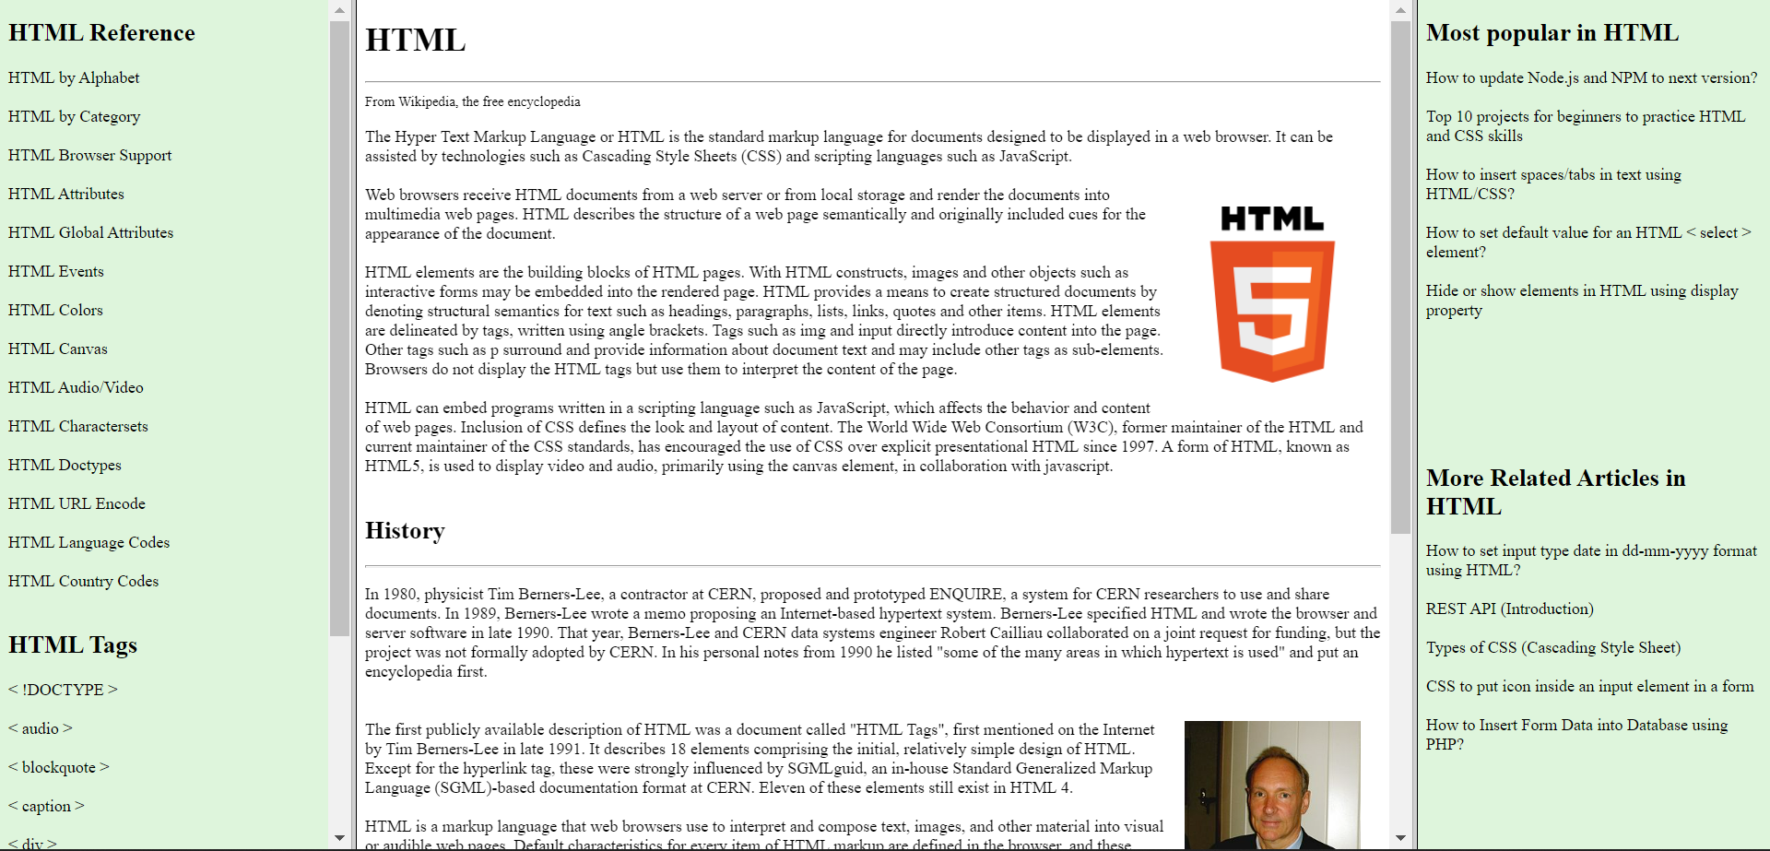

Tutorials Gallery-

<!DOCTYPE html>

<html lang="en">

<head>

    <meta charset="UTF-8">

    <meta http-equiv="X-UA-Compatible" content="IE=edge">

    <meta name="viewport" content="width=device-width, initial-scale=1.0">

    <title>Html</title>

</head>

<body style="background-color: gray; margin-bottom: 0%;">

    <div style="text-align:center; background-color: blue; font-size: 50px; margin: 0; color:white; padding: 4%;">

        <header>Tutorials Gallery</header>

    </div>

    <div style="text-align:center; height:400px; background-color:white; font-size: 20px; margin: 0;  padding: 0;">

        <table style="width: 100%; height: 400px;">

            <tr>

                <td style="color: blue; width:25%; text-align: start; vertical-align: top; padding-left: 20px; padding-top: 2%; border:none">

                    <a href="https://en.wikipedia.org/wiki/HTML">HTML</a><br>

                    <a href="https://en.wikipedia.org/wiki/css">CSS</a><br>

                    <a href="https://en.wikipedia.org/wiki/JavaScript">JavaScript</a><br>

                </td>

                <td style="text-align: initial; vertical-align:top; padding-left: 20px; border-left: dashed red;">

                    <h1>HTML</h1>

                    <section>

                        Both HTML and HTML5 are hypertext markup languages, primarily used to develop web pages or

                        applications. HTML5 is the latest version of HTML and supports new markup language

                        functionalities such as multimedia, new tags and elements as well as new APIs. HTML5 also

                        supports audio and video.

                    </section><br>

                    <section>

                        HTML5 was created to improve the WWW experience and give web developers more flexibility when

                        designing websites. In this part of the article, we will go over the significant improvements

                        introduced by the new version.

                    </section><br>

                    <section>

                        The consistent error handling in HTML5 has made a massive difference in this regard, with the

                        improved parsing algorithms used in HTML5 saving a large amount of both money and time.

                    </section>

                </td>

            </tr>

        </table>

    </div>

    <div style="text-align:center; background-color: blue; margin:0; color:white; padding:2%;"><br>

        <footer style="font-size:20px;">Copyright © javapoint.com</footer>

    </div>

</body>

</html>

Output-

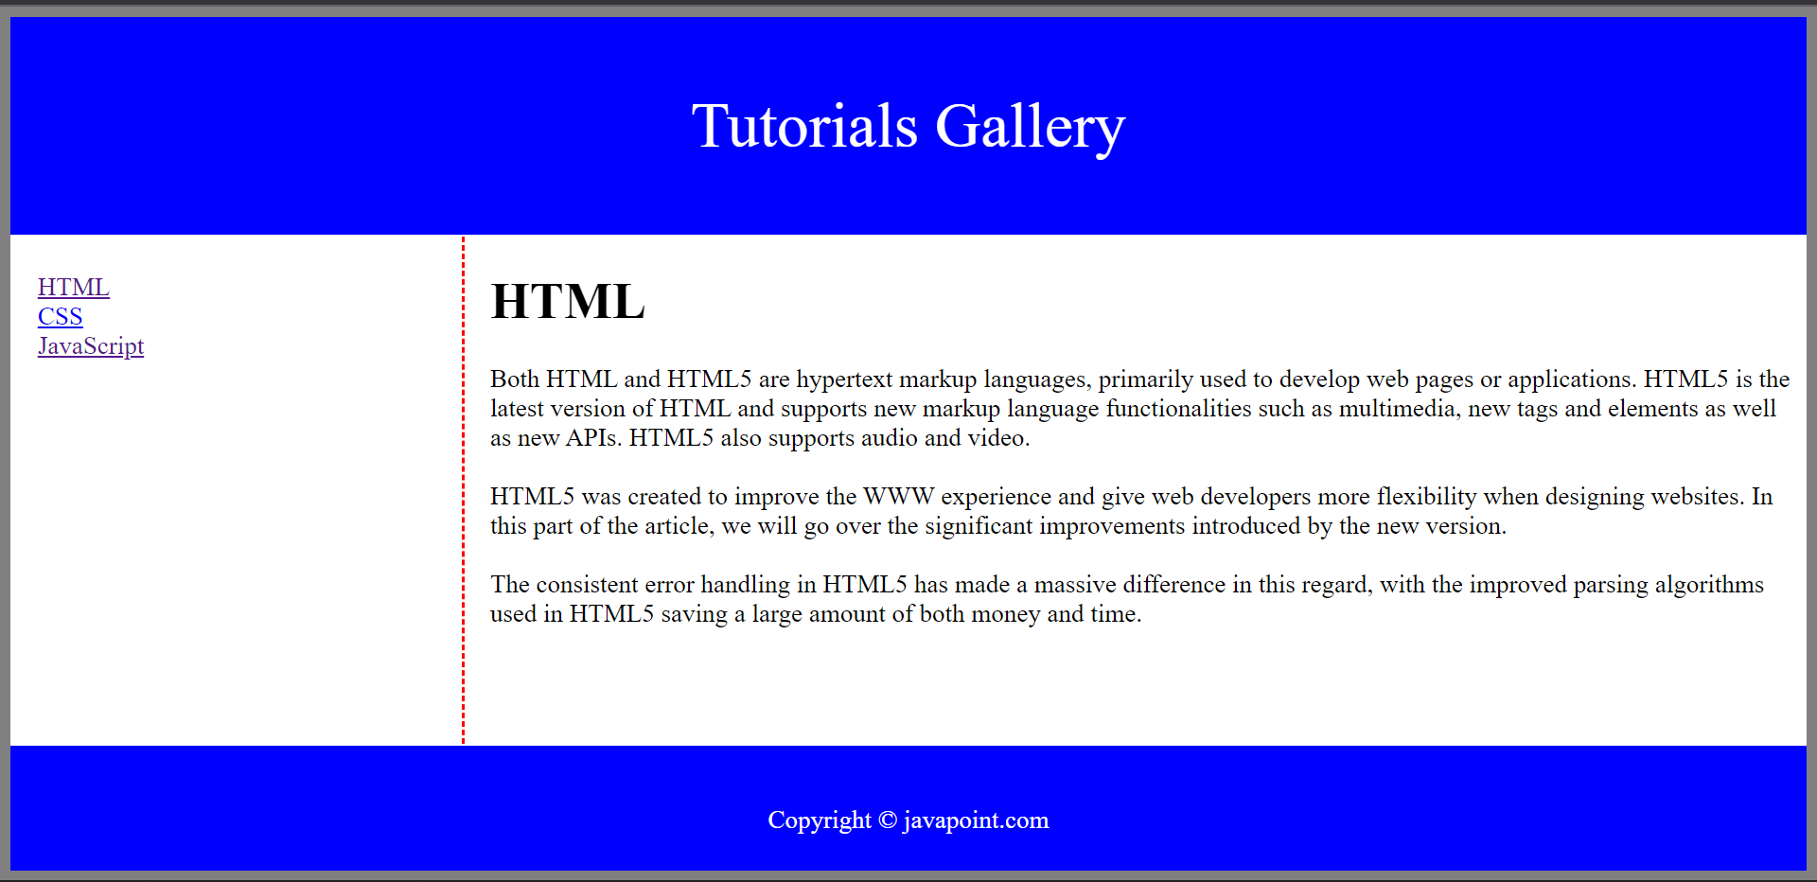

Experiment 3-

<!DOCTYPE html>

<html lang="en">

<head>

    <meta charset="UTF-8">

    <meta http-equiv="X-UA-Compatible" content="IE=edge">

    <meta name="viewport" content="width=device-width, initial-scale=1.0">

    <link rel="stylesheet" href="Experiment3.css">

    <title>Experiment 3</title>

</head>

<body class="header">

    <h1 style="color: black; text-align: center;">PERSONAL INFORMATION FORM</h1>

    <form>

        <div class="fs1">

            <fieldset>

                <legend style="color: black;">Personal Data</legend>

                <label for="name"><b>Name</b></label><br>

                <input type="text" id="name" name="name" placeholder="Enter your name"><br><br>

                <label for="age"><b>Age</b></label><br>

                <input type="number" id="age" name="age" min="0" placeholder="Enter your age"><br><br>

                <label for="address"><b>Address</b></label><br>

                <input type="text" id="address" name="address" placeholder="Enter your address"><br><br>

            </fieldset>

        </div>

        <div class="fs2">

            <fieldset>

                <legend style="color: black;">Preferences</legend>

                <div class="favsubject">

                    <label class="favs"><b>Favorite Subject</b></label><br>

                    <input type="radio" id="dc1" name="favsubject">

                    <label style="font-size: 20px;" for="dc1">DC-1</label><br>

                    <input type="radio" id="dc2" name="favsubject">

                    <label style="font-size: 20px;" for="dc3">DC-2</label><br>

                    <input type="radio" id="dc3" name="favsubject">

                    <label style="font-size: 20px;" for="dc3">DC-3</label><br>

                    <input type="radio" id="webd" name="favsubject">

                    <label style="font-size: 20px;" for="webd">Web-D</label><br>

                    <input type="radio" id="maths" name="favsubject">

                    <label style="font-size: 20px;" for="maths">Maths</label><br>

                    <input type="radio" id="phy" name="favsubject">

                    <label style="font-size: 20px;" for="phy">Physics</label><br>

                    <input type="radio" id="chem" name="favsubject">

                    <label style="font-size: 20px;" for="chem">Chemistry</label><br>

                    <input type="radio" id="eco" name="favsubject">

                    <label style="font-size: 20px;" for="eco">Economics</label><br><br>

                </div>

                <div class="favmovie">

                    <label class="favs"><b>Favorite Movie Genre</b></label><br>

                    <select name="movie" id="movie">

                        <option value="none">Select Genre</option>

                        <option value="comedy">Comedy</option>

                        <option value="Horror">Horror</option>

                        <option value="Thriller">Thriller</option>

                        <option value="Action">Action</option>

                        <option value="Documentary">Documentary</option>

                        <option value="Animation">Animation</option>

                    </select><br><br>

                </div>

                <div class="favsinger">

                    <label for="movie" class="favs"><b>Favorite Singer</b></label><br>

                    <input type="checkbox" id="TonyKakkar" name="singer" class="singer">

                    <label style="font-size: 20px;" for="TonyKakkar">Tony Kakkar</label><br>

                    <input type="checkbox" id="NehaKakkar" name="singer" class="singer">

                    <label style="font-size: 20px;" for="NehaKakkar">Neha Kakkar</label><br>

                    <input type="checkbox" id="SidhuMoosewala" name="singer" class="singer">

                    <label style="font-size: 20px;" for="SidhuMoosewala">Late Sidhu Moosewala</label><br>

                    <input type="checkbox" id="DhinchakPooja" name="singer" class="singer">

                    <label style="font-size: 20px;" for="DhinchakPooja">Dhinchak Pooja</label><br><br>

                </div>

            </fieldset>

        </div>

        <input type="submit" value="Submit" style="width: 100px; font-size: larger; border-style: solid; border-radius: 9px; margin: 2% 1% 5% 42%;">

        <input type="reset" value="Reset" style="width: 100px; margin-top: 2%; font-size: larger; margin-left: 1%; border-style: solid; border-radius: 9px;">

    </form>

</body>

</html>

Css-

.singer{

*text-align*: left;

}

.header{

*background-color*: #e8c0ec;

    /* text-align: center; */

}

.fs1{

*background-color*: rgb(255, 255, 255);

*font-size*: 25px;

*color*: black;

*margin-bottom*: 2%;

*width*: 60%;

*margin-left*: 20%;

*border-style*: solid;

*border-radius*: 9px;

}

.fs2{

*margin-top*: 2%;

*background-color*: rgb(255, 255, 255);

*font-size*: 25px;

*color*: black;

*width*: 60%;

*margin-left*: 20%;

*border-style*: solid;

*border-radius*: 9px;

}

.favsubject, .favmovie, .favsinger{

*margin*: 2%;

}

.favs{

*margin-bottom*: 2%;

}

input{

*height*: 30px;

}

select{

*height*: 30px;

}

Output-

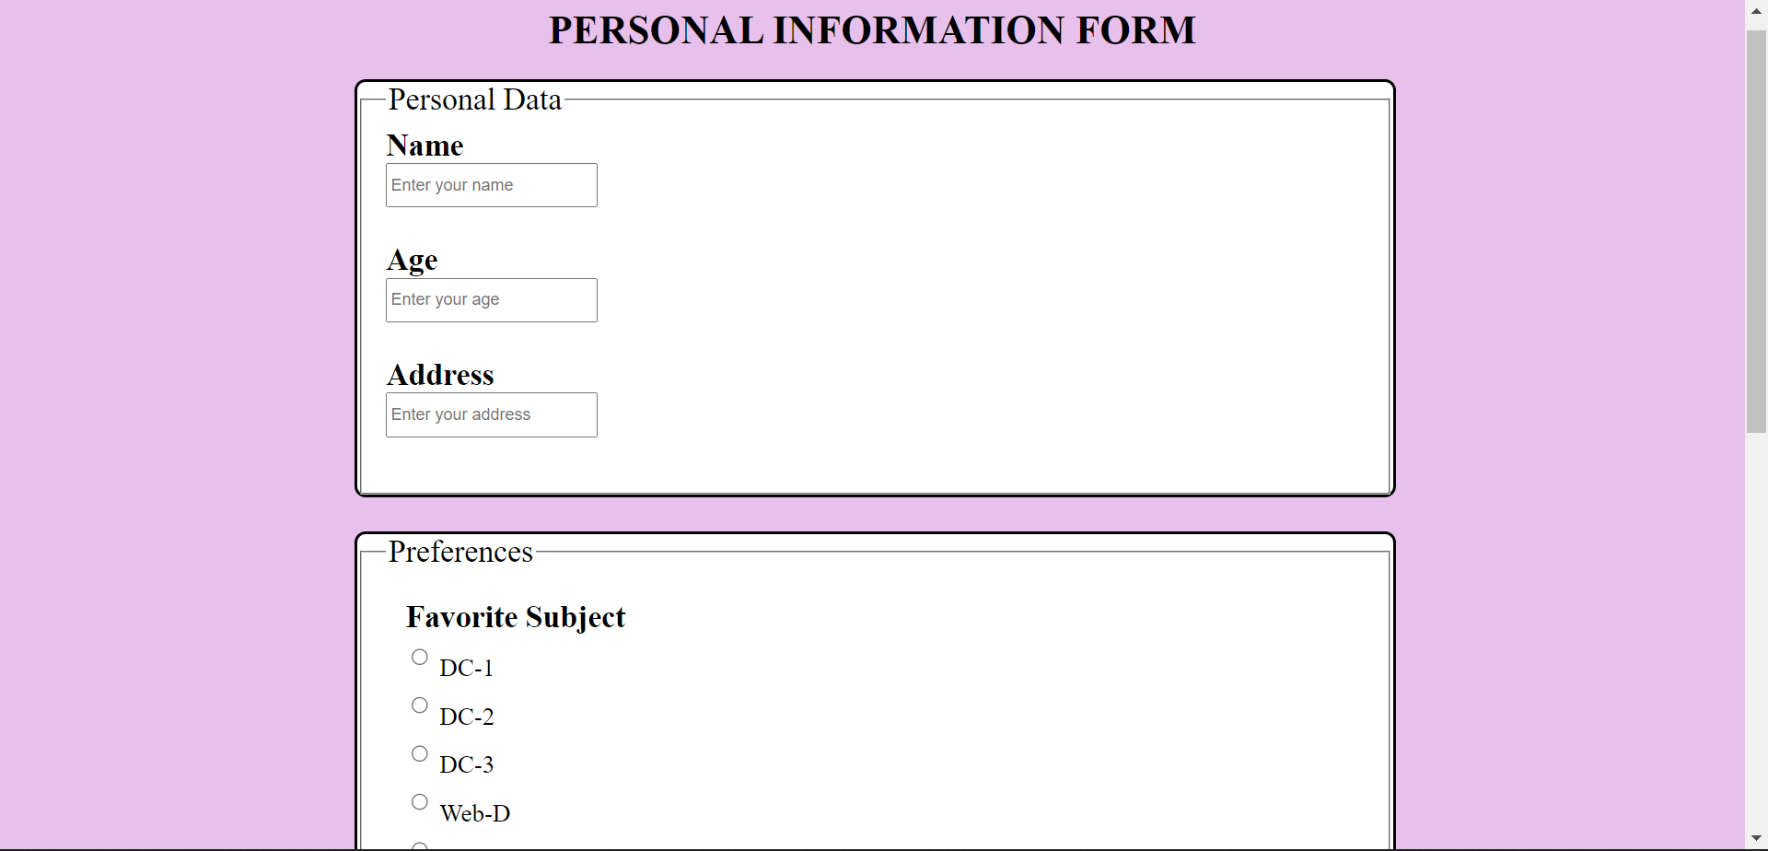

Experiment 4-

<!DOCTYPE html>

<html lang="en">

<head>

    <meta charset="UTF-8">

    <meta http-equiv="X-UA-Compatible" content="IE=edge">

    <meta name="viewport" content="width=device-width, initial-scale=1.0">

    <title>Image Map of NITKKR</title>

</head>

<body>

    <img src="campus.png" alt="campusmap" usemap="#campusmap">

    <map name="campusmap">

        <area target="_blank" shape="rect" coords="482, 285, 500, 463" href="infinitecorridor.html" alt="mallroad">

        <area target="_blank" shape="rect" coords="368, 56, 519, 219" href="sportscomplex.html" alt="sportscomplex">

        <area target="_blank" shape="circle" coords="850, 232, 15" href="main.html" alt="maingate">

        <area target="_blank" shape="circle" coords="577, 348, 22" href="oat.html" alt="oat">

        <area target="_blank" shape="poly" coords="70, 662, 134, 635, 194, 766, 144, 775" href="lake.html" alt="lake">

        <area target="_blank" shape="poly" coords="624, 255, 624, 507, 780, 507, 844, 255" href="hostel.html" alt="hostel">

    </map>

</body>

</html>

<!DOCTYPE html>

<html lang="en">

<head>

    <meta charset="UTF-8">

    <meta http-equiv="X-UA-Compatible" content="IE=edge">

    <meta name="viewport" content="width=device-width, initial-scale=1.0">

    <title>Hostels</title>

</head>

<body>

    <h1 style="text-align: center;">Hostels</h1>

    <img src="hostel1.jpg" alt="hostel1">

    <img src="hostel2.jpg" alt="hostel2">

    <img src="hostel3.jpg" alt="hostel3">

</body>

</html>

<!DOCTYPE html>

<html lang="en">

<head>

    <meta charset="UTF-8">

    <meta http-equiv="X-UA-Compatible" content="IE=edge">

    <meta name="viewport" content="width=device-width, initial-scale=1.0">

    <title>Infinite Corridor</title>

</head>

<body>

    <h1 style="text-align: center;">Infinite Corridor</h1>

    <img src="infinite1.jpg" alt="infinite1">

    <img src="infinite2.jpg" alt="infinite2">

    <img src="infinite3.jpg" alt="infinite3">

</body>

</html>

<!DOCTYPE html>

<html lang="en">

<head>

    <meta charset="UTF-8">

    <meta http-equiv="X-UA-Compatible" content="IE=edge">

    <meta name="viewport" content="width=device-width, initial-scale=1.0">

    <title>NIT Lake</title>

</head>

<body>

    <h1 style="text-align: center;">NIT Lake</h1>

    <img src="lake1.jpg" alt="lake1">

    <img src="lake2.jpg" alt="lake2">

</body>

</html>

<!DOCTYPE html>

<html lang="en">

<head>

    <meta charset="UTF-8">

    <meta http-equiv="X-UA-Compatible" content="IE=edge">

    <meta name="viewport" content="width=device-width, initial-scale=1.0">

    <title>NIT Gate</title>

</head>

<body>

    <h1 style="text-align: center;">NIT Gate</h1>

    <img src="main1.jpg" alt="main1">

    <img src="main2.jpg" alt="main2">

</body>

</html>

<!DOCTYPE html>

<html lang="en">

<head>

    <meta charset="UTF-8">

    <meta http-equiv="X-UA-Compatible" content="IE=edge">

    <meta name="viewport" content="width=device-width, initial-scale=1.0">

    <title>Open Air Theatre</title>

</head>

<body>

    <h1 style="text-align: center;">Open Air Theatre</h1>

    <img src="oat1.jpg" alt="oat1">

    <img src="oat2.jpg" alt="oat2">

</body>

</html>

<!DOCTYPE html>

<html lang="en">

<head>

    <meta charset="UTF-8">

    <meta http-equiv="X-UA-Compatible" content="IE=edge">

    <meta name="viewport" content="width=device-width, initial-scale=1.0">

    <title>Sports Complex</title>

</head>

<body>

    <h1 style="text-align: center;">Sports Complex</h1>

    <img src="sports1.jpg" alt="sports1">

    <img src="sports2.jpg" alt="sports2">

</body>

</html>

Output-

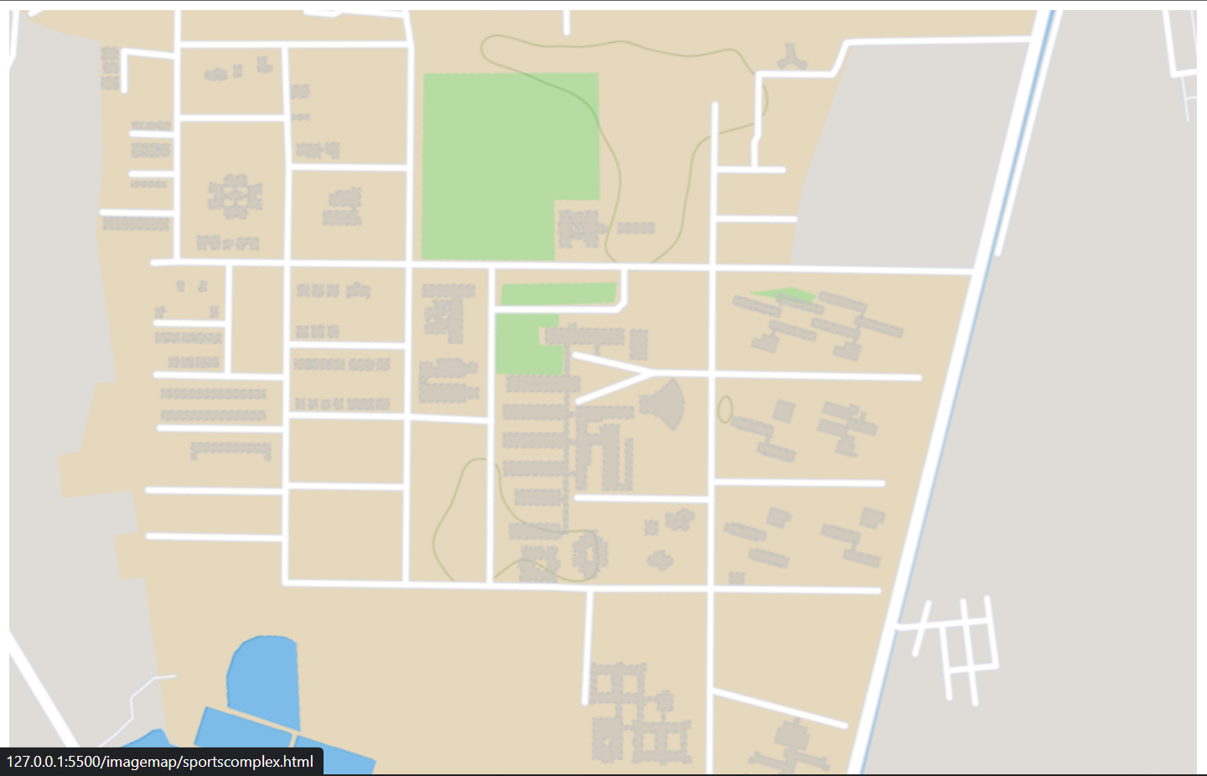

Time Table-

<!DOCTYPE html>

<html lang="en">

<head>

     <meta charset="UTF-8">

     <meta http-equiv="X-UA-Compatible" content="IE=edge">

     <meta name="viewport" content="width=device-width, initial-scale=1.0">

     <title>Experiment-4(b)</title>

     <style>

          .days {

*background-color*: blanchedalmond;

          }

     </style>

</head>

<body>

     <div style="text-align: center;">

          <h1>CS Time-Table</h1>

     </div>

     <table width="90%" border="2" style="text-align: center; margin-left: 5%;">

          <thead class="days">

               <tr>

                    <th colspan="12">MONDAY</th>

               </tr>

          </thead>

          <tbody>

               <tr>

                    <th></th>

                    <th></th>

                    <th>1</th>

                    <th>2</th>

                    <th>3</th>

                    <th>4</th>

                    <th>5</th>

                    <th>6</th>

                    <th>7</th>

                    <th>8</th>

                    <th>9</th>

                    <th>10</th>

               </tr>

               <tr>

                    <td rowspan="4">CS-A</td>

                    <td>1</td>

                    <td rowspan="4">MA-L</td>

                    <td rowspan="4">DC3-L</td>

                    <td rowspan="2" colspan="2">DC2-P</td>

                    <td></td>

                    <td rowspan="4">CH-L</td>

                    <td rowspan="2" colspan="2">DC3-P</td>

                    <td></td>

                    <td></td>

               </tr>

               <tr>

                    <td>2</td>

                    <td></td>

                    <td></td>

                    <td></td>

               </tr>

               <tr>

                    <td>3</td>

                    <td colspan="2" rowspan="2">DC3-P</td>

                    <td></td>

                    <td>EE-T</td>

                    <td></td>

                    <td>DC-T</td>

                    <td>PH-T</td>

               </tr>

               <tr>

                    <td>4</td>

                    <td></td>

                    <td>DC-T</td>

                    <td></td>

                    <td>EE-T</td>

                    <td>CH-T</td>

               </tr>

          </tbody>

          <thead class="days">

               <tr>

                    <th colspan="12">TUESDAY</th>

               </tr>

          </thead>

          <tbody>

               <tr>

                    <th></th>

                    <th></th>

                    <th>1</th>

                    <th>2</th>

                    <th>3</th>

                    <th>4</th>

                    <th>5</th>

                    <th>6</th>

                    <th>7</th>

                    <th>8</th>

                    <th>9</th>

                    <th>10</th>

               </tr>

               <tr>

                    <td rowspan="4">CS-A</td>

                    <td>1</td>

                    <td rowspan="4" colspan="3">WD-P</td>

                    <td></td>

                    <td rowspan="4">DC3-L</td>

                    <td></td>

                    <td rowspan="4">DC1-L</td>

                    <td rowspan="4">DC2-L</td>

                    <td>EE-T</td>

                    <td>CH-T</td>

               </tr>

               <tr>

                    <td>2</td>

                    <td></td>

                    <td></td>

                    <td>PH-T</td>

                    <td>EE-T</td>

               </tr>

               <tr>

                    <td>3</td>

                    <td></td>

                    <td></td>

                    <td>CH-T</td>

                    <td>MA-T</td>

               </tr>

               <tr>

                    <td>4</td>

                    <td></td>

                    <td></td>

                    <td>MA-T</td>

                    <td>PH-T</td>

               </tr>

          </tbody>

          <thead class="days">

               <tr>

                    <th colspan="12">WEDNESDAY</th>

               </tr>

          </thead>

          <tbody>

               <tr>

                    <th></th>

                    <th></th>

                    <th>1</th>

                    <th>2</th>

                    <th>3</th>

                    <th>4</th>

                    <th>5</th>

                    <th>6</th>

                    <th>7</th>

                    <th>8</th>

                    <th>9</th>

                    <th>10</th>

               </tr>

               <tr>

                    <td rowspan="4">CS-A</td>

                    <td>1</td>

                    <td rowspan="4" colspan="2">PH-P</td>

                    <td rowspan="4">PH-L</td>

                    <td rowspan="4">EE-L</td>

                    <td></td>

                    <td rowspan="4">MA-L</td>

                    <td></td>

                    <td></td>

                    <td>MA-T</td>

                    <td></td>

               </tr>

               <tr>

                    <td>2</td>

                    <td></td>

                    <td></td>

                    <td></td>

                    <td>DC-T</td>

                    <td>CH-T</td>

               </tr>

               <tr>

                    <td>3</td>

                    <td></td>

                    <td rowspan="2" colspan="2">DC2-P</td>

                    <td></td>

                    <td></td>

               </tr>

               <tr>

                    <td>4</td>

                    <td></td>

                    <td></td>

                    <td></td>

               </tr>

          </tbody>

          <thead class="days">

               <tr>

                    <th colspan="12">THURSDAY</th>

               </tr>

          </thead>

          <tbody>

               <tr>

                    <th></th>

                    <th></th>

                    <th>1</th>

                    <th>2</th>

                    <th>3</th>

                    <th>4</th>

                    <th>5</th>

                    <th>6</th>

                    <th>7</th>

                    <th>8</th>

                    <th>9</th>

                    <th>10</th>

               </tr>

               <tr>

                    <td rowspan="4">CS-A</td>

                    <td>1</td>

                    <td>DC-T</td>

                    <td>PH-T</td>

                    <td rowspan="4">DC3-L</td>

                    <td rowspan="4">DC1-L</td>

                    <td rowspan="4">EE-L</td>

                    <td></td>

                    <td rowspan="4">DC2-L</td>

                    <td rowspan="4">MA-L</td>

                    <td></td>

                    <td></td>

               </tr>

               <tr>

                    <td>2</td>

                    <td></td>

                    <td></td>

                    <td></td>

                    <td>MA-T</td>

                    <td></td>

               </tr>

               <tr>

                    <td>3</td>

                    <td></td>

                    <td></td>

                    <td></td>

                    <td></td>

                    <td></td>

               </tr>

               <tr>

                    <td>4</td>

                    <td></td>

                    <td></td>

                    <td></td>

                    <td></td>

                    <td></td>

               </tr>

          </tbody>

          <thead class="days">

               <tr>

                    <th colspan="12">FRIDAY</th>

               </tr>

          </thead>

          <tbody>

               <tr>

                    <th></th>

                    <th></th>

                    <th>1</th>

                    <th>2</th>

                    <th>3</th>

                    <th>4</th>

                    <th>5</th>

                    <th>6</th>

                    <th>7</th>

                    <th>8</th>

                    <th>9</th>

                    <th>10</th>

               </tr>

               <tr>

                    <td rowspan="4">CS-A</td>

                    <td>1</td>

                    <td rowspan="4">DC2-L</td>

                    <td rowspan="4">CH-L</td>

                    <td rowspan="4">DC1-L</td>

                    <td rowspan="4">WD-L</td>

                    <td rowspan="4">PH-L</td>

                    <td></td>

                    <td rowspan="4" colspan="2">CH-P</td>

                    <td></td>

                    <td></td>

               </tr>

               <tr>

                    <td>2</td>

                    <td></td>

                    <td></td>

                    <td></td>

               </tr>

               <tr>

                    <td>3</td>

                    <td></td>

                    <td></td>

                    <td></td>

               </tr>

               <tr>

                    <td>4</td>

                    <td></td>

                    <td></td>

                    <td></td>

               </tr>

          </tbody>

          <thead class="days">

               <tr>

                    <th colspan="12">SATURDAY</th>

               </tr>

          </thead>

          <tbody>

               <tr>

                    <th></th>

                    <th></th>

                    <th>1</th>

                    <th>2</th>

                    <th>3</th>

                    <th>4</th>

                    <th>5</th>

                    <th>6</th>

                    <th>7</th>

                    <th>8</th>

                    <th>9</th>

                    <th>10</th>

               </tr>

               <tr>

                    <td rowspan="4">CS-A</td>

                    <td>1</td>

                    <td rowspan="4">WD-L</td>

                    <td rowspan="4">EE-L</td>

                    <td rowspan="4">MA-L</td>

                    <td rowspan="4">DC1-L</td>

                    <td rowspan="4">DC2-L</td>

                    <td></td>

                    <td rowspan="4">DC3-L</td>

                    <td rowspan="4">CH-L</td>

                    <td rowspan="4">PH-L</td>

                    <td></td>

               </tr>

               <tr>

                    <td>2</td>

                    <td></td>

                    <td></td>

               </tr>

               <tr>

                    <td>3</td>

                    <td></td>

                    <td></td>

               </tr>

               <tr>

                    <td>4</td>

                    <td></td>

                    <td></td>

               </tr>

          </tbody>

     </table>

     </div>

</body>

</html>

Output-

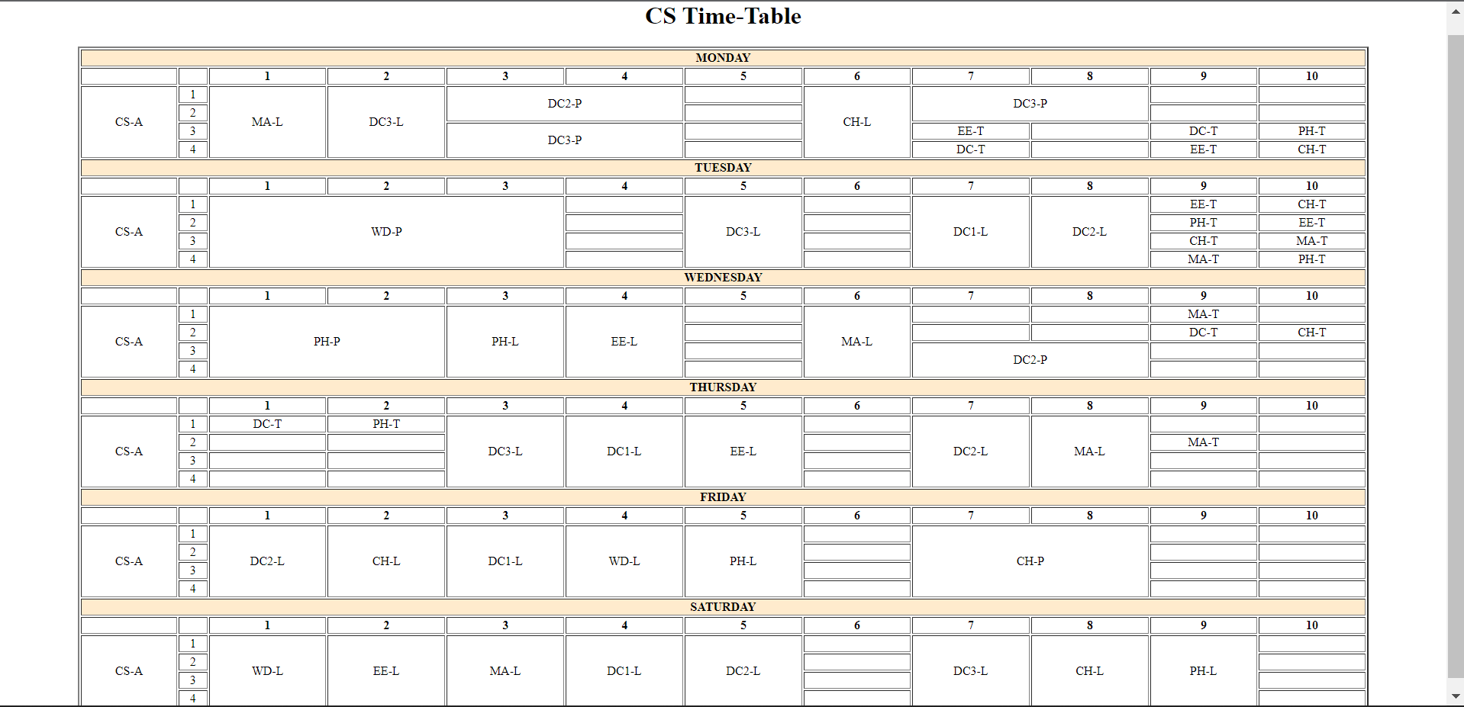

Experiment 5-

<!DOCTYPE html>

<html lang="en">

<head>

    <meta charset="UTF-8">

    <meta http-equiv="X-UA-Compatible" content="IE=edge">

    <meta name="viewport" content="width=device-width, initial-scale=1.0">

    <title>Experiment 3</title>

    <style>

        .singer{

*text-align*: left;

        }

        .header{

*background-color*: #e8c0ec;

        }

        .fs1{

*background-color*: rgb(255, 255, 255);

*font-size*: 25px;

*color*: black;

*margin-bottom*: 2%;

*width*: 60%;

*margin-left*: 20%;

*border-style*: solid;

*border-radius*: 9px;

        }

        .fs2{

*margin-top*: 2%;

*background-color*: rgb(255, 255, 255);

*font-size*: 25px;

*color*: black;

*width*: 60%;

*margin-left*: 20%;

*border-style*: solid;

*border-radius*: 9px;

        }

        .favsubject, .favmovie, .favsinger{

*margin*: 2%;

        }

        .favs{

*margin-bottom*: 2%;

        }

        input{

*height*: 30px;

        }

        select{

*height*: 30px;

        }

        sup{

*font-size*: small;

*color*: red;

        }

    </style>

    <script>

*function* validateform(){

*let* x = document.forms["form1"]["name"].value;

*let* y = document.forms["form1"]["age"].value;

*let* z = document.forms["form1"]["address"].value;

            if(x.length < 3){

                alert("Length of name is should be greater than or equal to 3 characters");

                return false;

            }

            if(y<0 || y>150){

                alert("Age should be in range of 0 to 150");

                return false;

            }

            if(z.contains(',')){

                alert("Your address does not contain commas (,)");

                return false;

            }

            if(z.length < 3){

                alert("Length of your address is very small");

                return false;

            }

        }

    </script>

</head>

<body class="header">

    <h1 style="color: black; text-align: center;">PERSONAL INFORMATION FORM</h1>

    <form name="form1" onsubmit="return validateform()">

        <div class="fs1">

            <fieldset>

                <legend style="color: black;">Personal Data</legend>

                <label for="name"><b>Name</b> <sup>*required</sup></label><br>

                <input type="text" id="name" name="name" placeholder="Enter your name" required><br><br>

                <label for="age"><b>Age</b> <sup>*required</sup></label><br>

                <input type="number" id="age" name="age" placeholder="Enter your age" required><br><br>

                <label for="address"><b>Address</b> <sup>*required</sup></label><br>

                <input type="text" id="address" name="address" placeholder="Enter your address" required><br><br>

            </fieldset>

        </div>

        <div class="fs2">

            <fieldset>

                <legend style="color: black;">Preferences</legend>

                <div class="favsubject">

                    <label class="favs"><b>Favorite Subject</b></label><br>

                    <input type="radio" id="dc1" name="favsubject">

                    <label style="font-size: 20px;" for="dc1">DC-1</label><br>

                    <input type="radio" id="dc2" name="favsubject">

                    <label style="font-size: 20px;" for="dc3">DC-2</label><br>

                    <input type="radio" id="dc3" name="favsubject">

                    <label style="font-size: 20px;" for="dc3">DC-3</label><br>

                    <input type="radio" id="webd" name="favsubject">

                    <label style="font-size: 20px;" for="webd">Web-D</label><br>

                    <input type="radio" id="maths" name="favsubject">

                    <label style="font-size: 20px;" for="maths">Maths</label><br>

                    <input type="radio" id="phy" name="favsubject">

                    <label style="font-size: 20px;" for="phy">Physics</label><br>

                    <input type="radio" id="chem" name="favsubject">

                    <label style="font-size: 20px;" for="chem">Chemistry</label><br>

                    <input type="radio" id="eco" name="favsubject">

                    <label style="font-size: 20px;" for="eco">Economics</label><br><br>

                </div>

                <div class="favmovie">

                    <label class="favs"><b>Favorite Movie Genre</b></label><br>

                    <select name="movie" id="movie">

                        <option value="none">Select Genre</option>

                        <option value="comedy">Comedy</option>

                        <option value="Horror">Horror</option>

                        <option value="Thriller">Thriller</option>

                        <option value="Action">Action</option>

                        <option value="Documentary">Documentary</option>

                        <option value="Animation">Animation</option>

                    </select><br><br>

                </div>

                <div class="favsinger">

                    <label for="movie" class="favs"><b>Favorite Singer</b></label><br>

                    <input type="checkbox" id="TonyKakkar" name="singer" class="singer">

                    <label style="font-size: 20px;" for="TonyKakkar">Tony Kakkar</label><br>

                    <input type="checkbox" id="NehaKakkar" name="singer" class="singer">

                    <label style="font-size: 20px;" for="NehaKakkar">Neha Kakkar</label><br>

                    <input type="checkbox" id="SidhuMoosewala" name="singer" class="singer">

                    <label style="font-size: 20px;" for="SidhuMoosewala">Late Sidhu Moosewala</label><br>

                    <input type="checkbox" id="DhinchakPooja" name="singer" class="singer">

                    <label style="font-size: 20px;" for="DhinchakPooja">Dhinchak Pooja</label><br><br>

                </div>

            </fieldset>

        </div>

        <input type="submit" value="Submit" style="width: 100px; font-size: larger; border-style: solid; border-radius: 9px; margin: 2% 1% 5% 42%;">

        <input type="reset" value="Reset" style="width: 100px; margin-top: 2%; font-size: larger; margin-left: 1%; border-style: solid; border-radius: 9px;">

    </form>

</body>

</html>

Output-

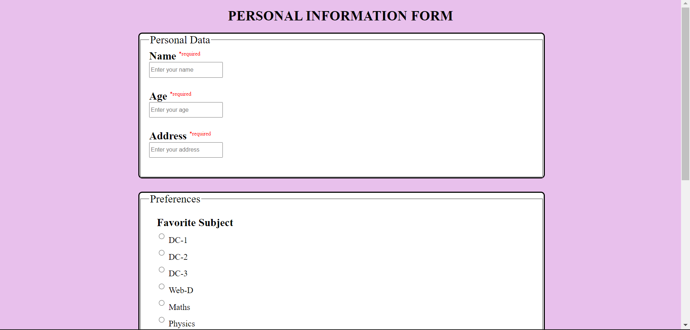

<!DOCTYPE html>

<html lang="en">

<head>

    <meta charset="UTF-8">

    <meta http-equiv="X-UA-Compatible" content="IE=edge">

    <meta name="viewport" content="width=device-width, initial-scale=1.0">

    <title>Information box</title>

</head>

<body>

    <img src="/imagemap/lake1.jpg" alt="lake" onload="myfunc()">

    <script>

*function* myfunc(){

            alert("Your image has been loaded :)");

        }

    </script>

</body>

</html>

Output-

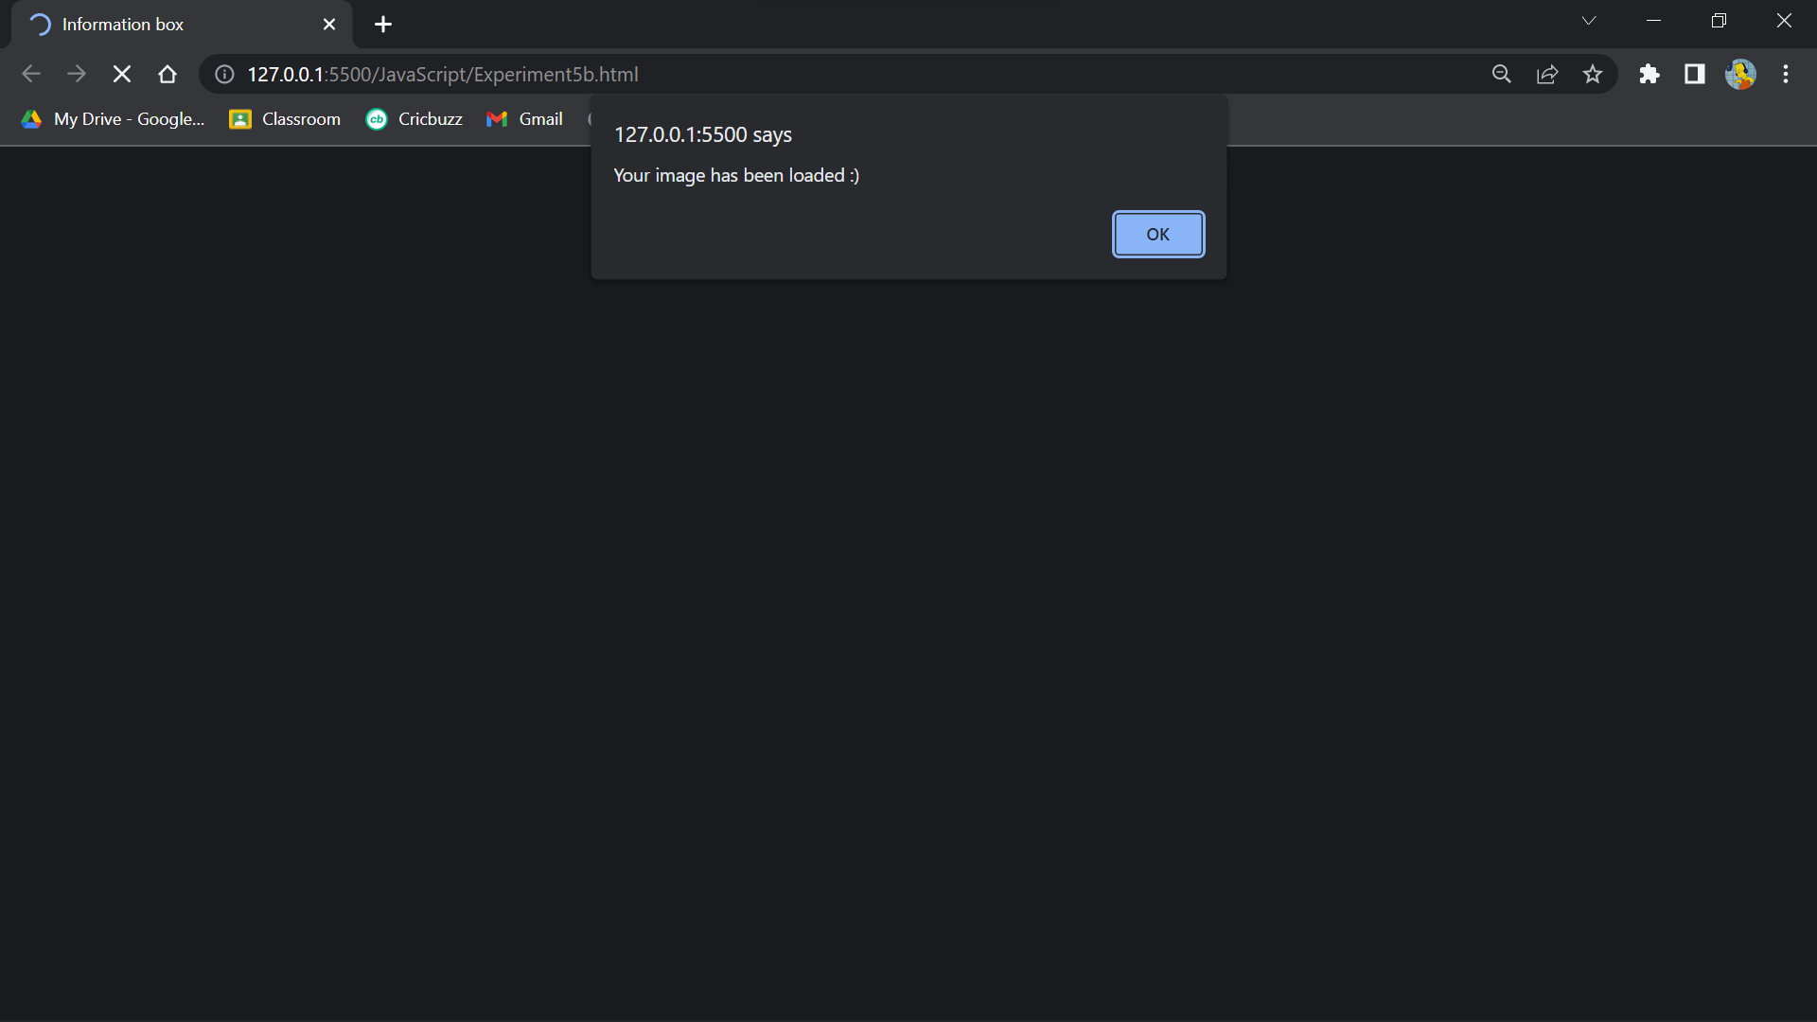

<!DOCTYPE html>

<html lang="en">

<head>

    <meta charset="UTF-8">

    <meta http-equiv="X-UA-Compatible" content="IE=edge">

    <meta name="viewport" content="width=device-width, initial-scale=1.0">

    <title>Background change</title>

    <script>

*let* myInterval = setInterval(setColor, 500);

*function* setColor() {

*let* x = document.body;

            x.style.backgroundColor = x.style.backgroundColor == "yellow" ? "pink" : "yellow";

        }

*function* stopColor() {

            clearInterval(myInterval);

        }

    </script>

</head>

<body>

    <input type="button" onclick="stopColor()" value="Stop Toggling">

</body>

</html>

Output-

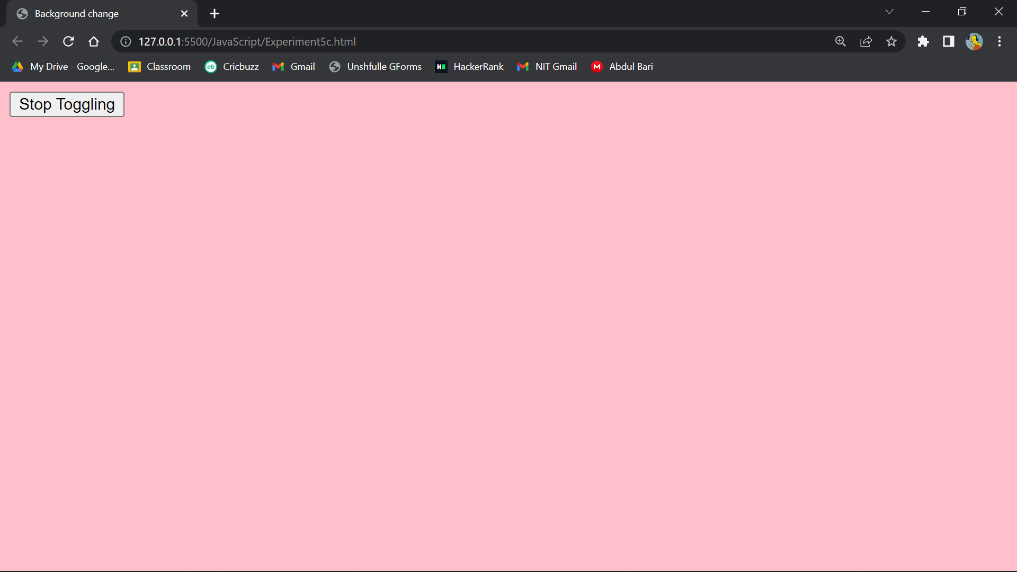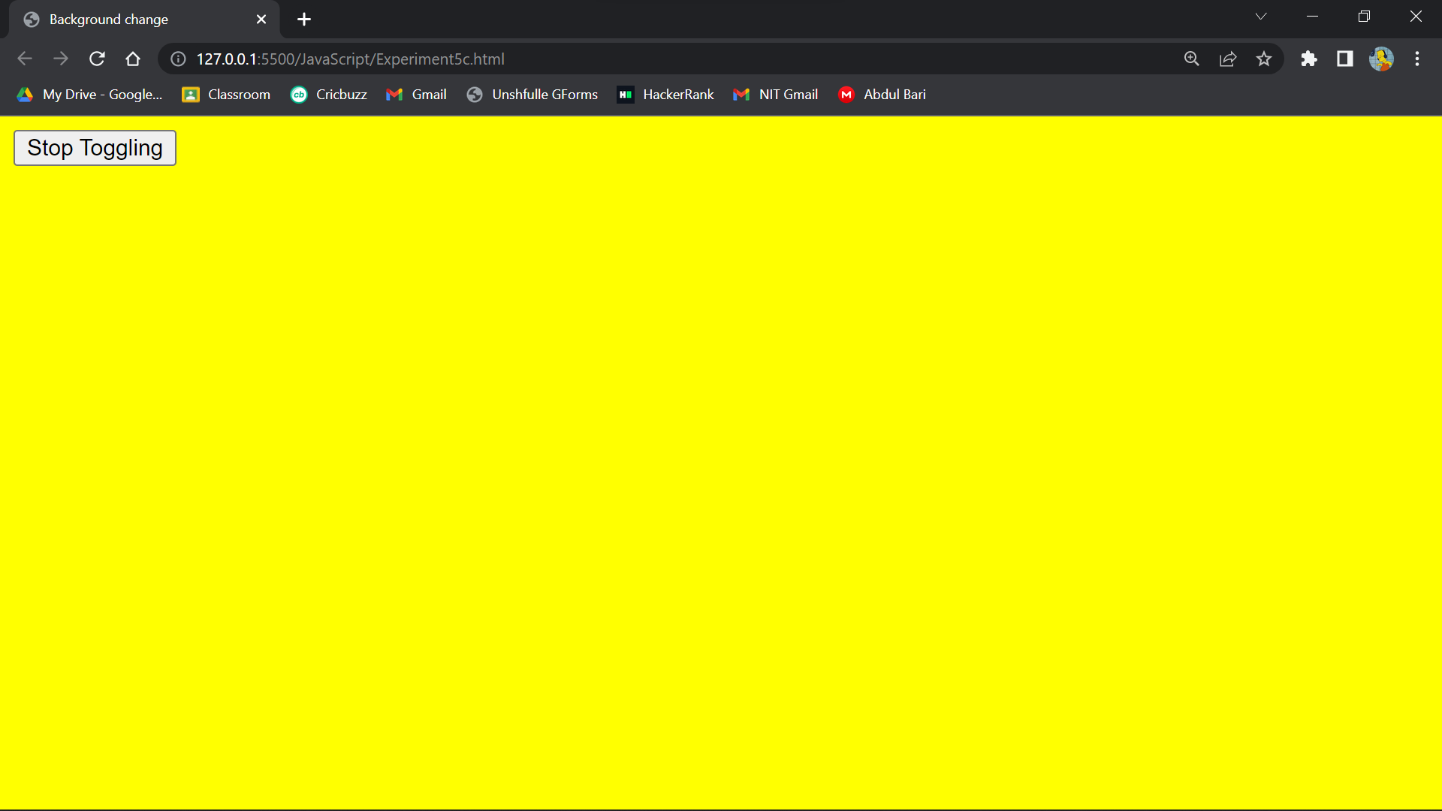

<!DOCTYPE html>

<html lang="en">

<head>

    <meta charset="UTF-8">

    <meta http-equiv="X-UA-Compatible" content="IE=edge">

    <meta name="viewport" content="width=device-width, initial-scale=1.0">

    <title>Dynamic</title>

    <style>

        div{

*background-color*: rgb(212, 212, 212);

*margin*: 2%;

*text-align*: center;

*padding*: 3%;

        }

    </style>

</head>

<body>

    <div onmouseenter="bo()">

        <span id="bold">This text should be bold</span>

    </div>

    <div onmouseover="it()">

        <span id="italic">This text should be italic</span>

    </div>

    <div onmouseenter="un()">

        <span id="underline">This text should be underlined</span>

    </div>

    <script>

*let* b = document.getElementById("bold");

*let* i = document.getElementById("italic");

*let* u = document.getElementById("underline");

*function* bo(){

            if(b.style.fontWeight == "normal")

                b.style.fontWeight = "bold";

            else

                b.style.fontWeight = "normal";

        }

*function* it(){

            if(i.style.fontStyle == "normal")

                i.style.fontStyle = "italic";

            else

                i.style.fontStyle = "normal";

        }

*function* un(){

            if(u.style.textDecoration == "none")

                u.style.textDecoration = "underline";

            else

                u.style.textDecoration = "none";

        }

    </script>

</body>

</html>

Output-



<!DOCTYPE html>

<html lang="en">

<head>

    <meta charset="UTF-8">

    <meta http-equiv="X-UA-Compatible" content="IE=edge">

    <meta name="viewport" content="width=device-width, initial-scale=1.0">

    <title>Hidden Div</title>

    <style>

        table{

*width*: 90%;

*text-align*: center;

*font-size*: 25px;

*margin-left*: 6%;

*margin-top*: 2%;

        }

        #photodiv{

*margin-top*: 2%;

*margin-left*: 20%;

*height*: 500px;

        }

    </style>

</head>

<body>

    <table>

        <tr>

            <td><div id="dhoni" onclick="dh()">MS Dhoni</div></td>

            <td><div id="kohli" onclick="ko()">Virat Kohli</div></td>

            <td><div id="rohit" onclick="rs()">Rohit Sharma</div></td>

        </tr>

    </table>

    <div id="photodiv"></div>

    <script>

*let* d = document.getElementById("dhoni");

*let* k = document.getElementById("kohli");

*let* r = document.getElementById("rohit");

*function* dh(){

            document.getElementById("photodiv").innerHTML = '<img src="msdhoni.png" alt="msd">';

            d.style.color = "red";

            k.style.color = "black";

            r.style.color = "black";

        }

*function* ko(){

            document.getElementById("photodiv").innerHTML = '<img src="viratkohli.png" alt="vk">';

            k.style.color = "red";

            d.style.color = "black";

            r.style.color = "black";

        }

*function* rs(){

            document.getElementById("photodiv").innerHTML = '<img src="rohitsharma.png" alt="hitman">';

            r.style.color = "red";

            d.style.color = "black";

            k.style.color = "black";

        }

    </script>

</body>

</html>

Output-

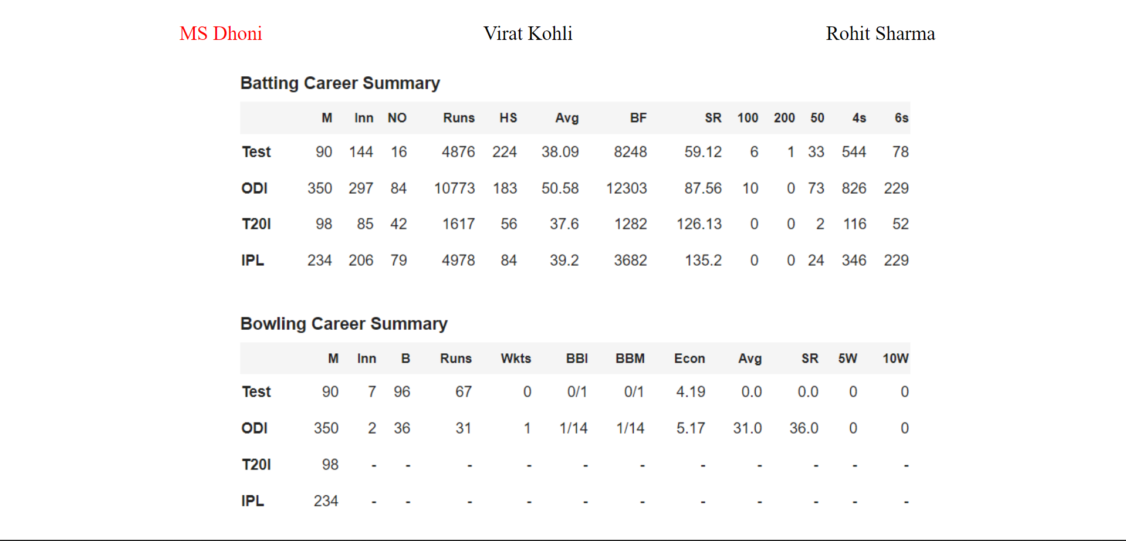

<!DOCTYPE html>

<html lang="en">

<head>

    <meta charset="UTF-8">

    <meta http-equiv="X-UA-Compatible" content="IE=edge">

    <meta name="viewport" content="width=device-width, initial-scale=1.0">

    <title>Popup Boxes</title>

</head>

<body>

    <div id="text"></div>

    <script>

        for(*let* i=0; i<10; i++){

            alert("This is alert #"+(i+1));

        }

    </script>

</body>

</html>

Output-

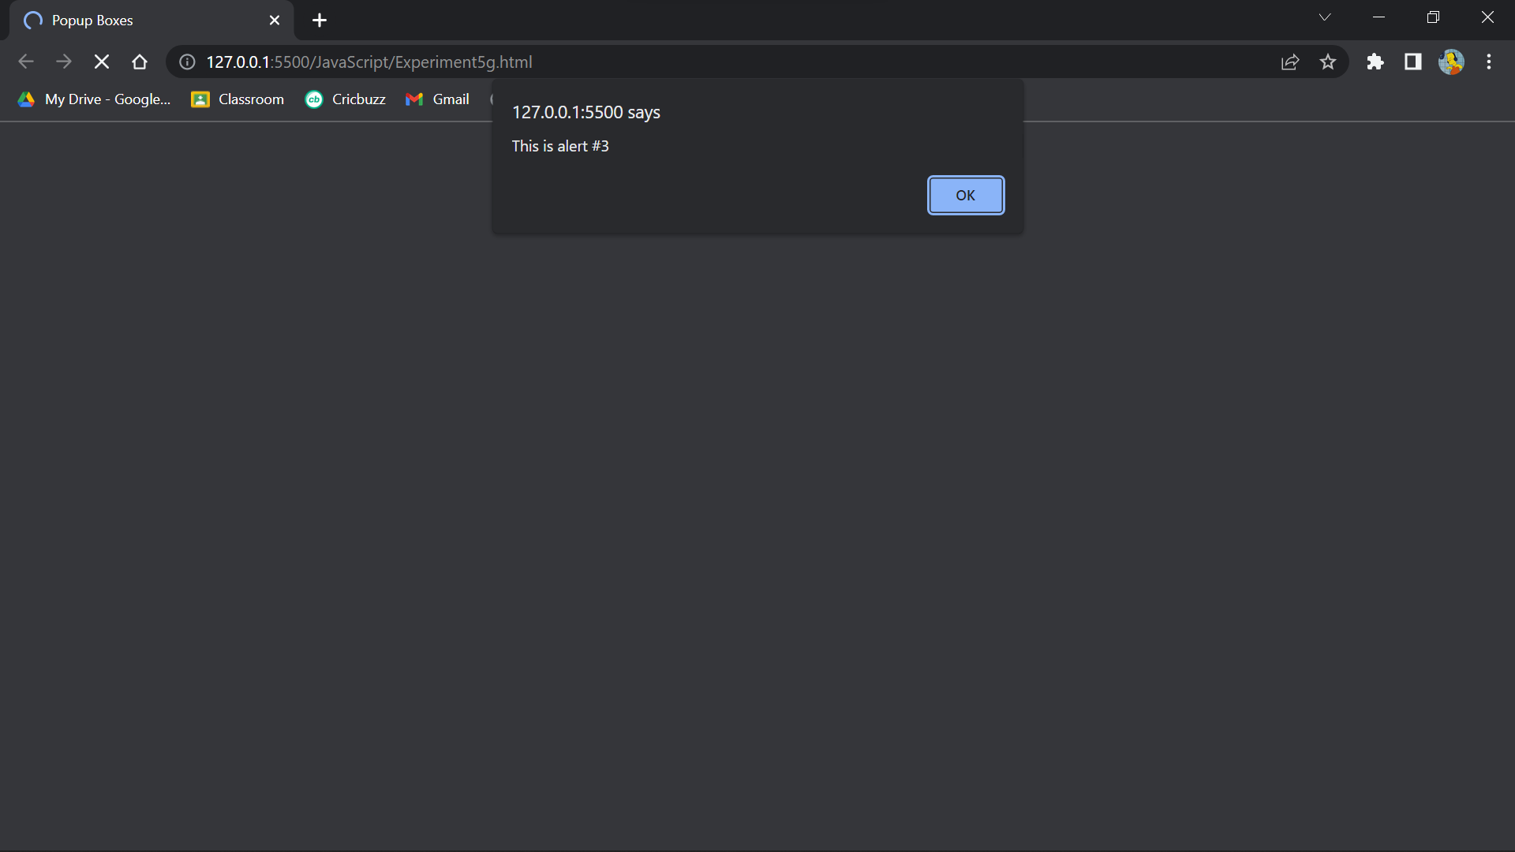

<!DOCTYPE html>

<html>

<title>Online HTML Editor</title>

<head>

    <style>

        .hello {

*text-align*: center;

*background-color*: black;

*color*: aqua;

        }

        .subhello1 {

*text-align*: center;

*height*: 100px;

*width*: 200px

        }

        .subhello2 {

*text-align*: center;

*height*: 100px;

*width*: 200px

        }

        .subhello3 {

*text-align*: center;

*height*: 100px;

*width*: 200px

        }

        .subhello4 {

*text-align*: center;

*height*: 100px;

*width*: 200px

        }

        .subhello5 {

*text-align*: center;

*height*: 100px;

*width*: 200px

        }

    </style>

</head>

<body>

    <div class="hello">

        <button id="btn1" onclick="fun1()" class="subhello1">Addition</button><br>

        <hr>

        <button id="btn2" onclick="fun2()" class="subhello2">Subtraction</button><br>

        <hr>

        <button id="btn3" onclick="fun3()" class="subhello3">Multiplication</button><br>

        <hr>

        <button id="btn4" onclick="fun4()" class="subhello4">Division</button><br>

        <hr>

        <button id="btn5" onclick="fun5(3.3,4.5)" class="subhello4">Addition of two float numbers</button><br>

        <hr>

        <button id="btn5" onclick="fun5(3,4)" class="subhello5">Addition of two integer numbers</button><br>

        <hr>

    </div>

    <script>

*function* fun1() {

*var* a = parseInt(prompt("Enter 1st value: "));

*var* b = parseInt(prompt("Enter 2nd value: "));

            document.getElementById("btn1").innerHTML = a + b;

        }

*function* fun2() {

*var* a = parseInt(prompt("Enter 1st value: "));

*var* b = parseInt(prompt("Enter 2nd value: "));

            document.getElementById("btn2").innerHTML = a - b;

        }

*function* fun3() {

*var* a = parseInt(prompt("Enter 1st value: "));

*var* b = parseInt(prompt("Enter 2nd value: "));

            document.getElementById("btn3").innerHTML = a * b;

        }

*function* fun4() {

*var* a = parseInt(prompt("Enter 1st value: "));

*var* b = parseInt(prompt("Enter 2nd value: "));

            document.getElementById("btn4").innerHTML = a / b;

        }

*function* fun5(*a*, *b*) {

            document.getElementById("btn5").innerHTML = *a* + *b*;

            alert("Addition of float numbers are: " + (*a* + *b*));

        }

    </script>

</body>

</html>

Output-

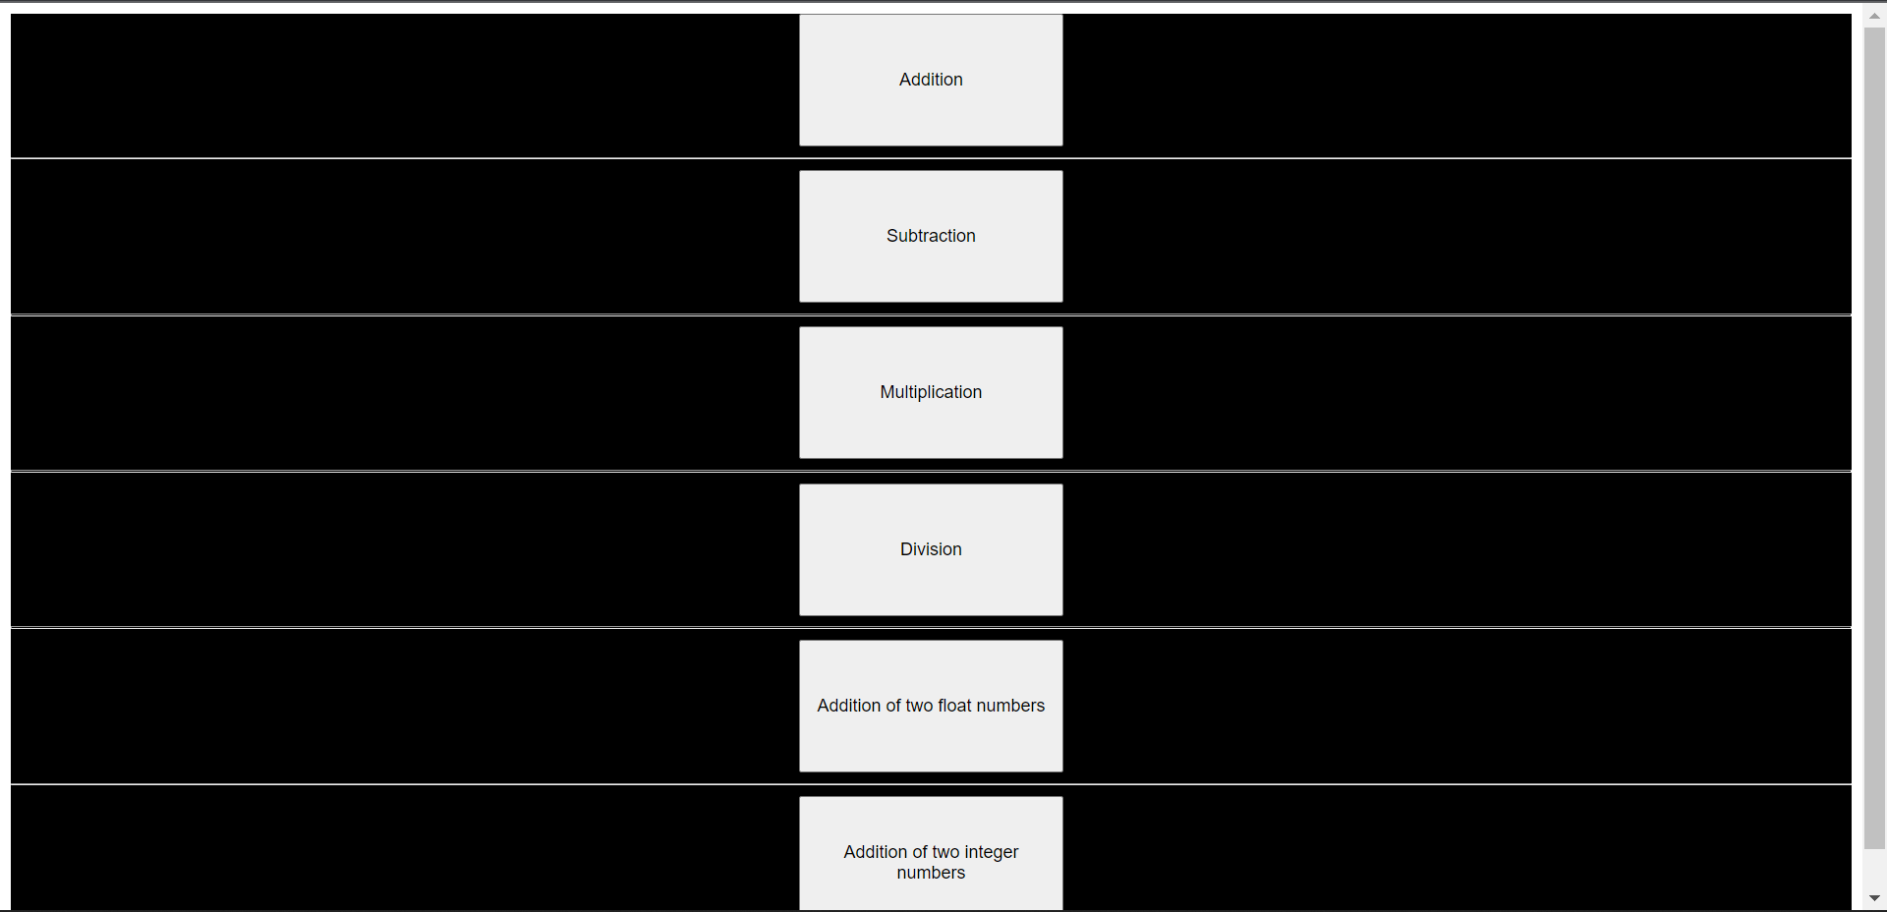

Experiment 6-

<!DOCTYPE html>

<html lang="en">

<head>

    <meta charset="UTF-8">

    <meta http-equiv="X-UA-Compatible" content="IE=edge">

    <meta name="viewport" content="width=device-width, initial-scale=1.0">

    <title>Experiment 6(a) & (b)</title>

    <style>

        body{

*background-color*: beige;

        }

        h1{

*text-align*: center;

*color*: brown;

        }

        p{

*font-size*: large;

*text-align*: center;

        }

        button{

*margin-left*: 45%;

*width*: 150px;

*height*: 30px;

*background-color*: rgb(211, 222, 244);

        }

    </style>

</head>

<body>

    <h1>Experiment 6(a) & (b)</h1>

    <p>Number 1: <span id="num1"></span><br><br></p>

    <p>Number 2: <span id="num2"></span><br><br></p>

    <button onclick="func1()">Calculate</button><br><br>

    <p>Quotient: <span id="quo"></span><br></p>

    <p>Remainder: <span id="rem"></span></p>

    <hr>

    <button onclick="spaces()">Add Spaces</button><br>

    <div id="num3" style="margin-left: 45%;"></div>

    <script>

*let* a = parseInt(prompt("Enter number 1: "));

*let* b = parseInt(prompt("Enter number 2: "));

        document.getElementById("num1").innerHTML = a;

        document.getElementById("num2").innerHTML = b;

*function* func1(){

            document.getElementById("quo").innerHTML = a/b - (a%b)/b;

            document.getElementById("rem").innerHTML = a%b;

        }

*function* spaces(){

*let* x = parseInt(prompt("Enter a number: "));

*let* str = *String*(x);

            for(*let* i=0; i<str.length; i++){

                document.getElementById("num3").innerHTML += str[i] + ' ';

            }

        }

    </script>

</body>

</html>

Output-

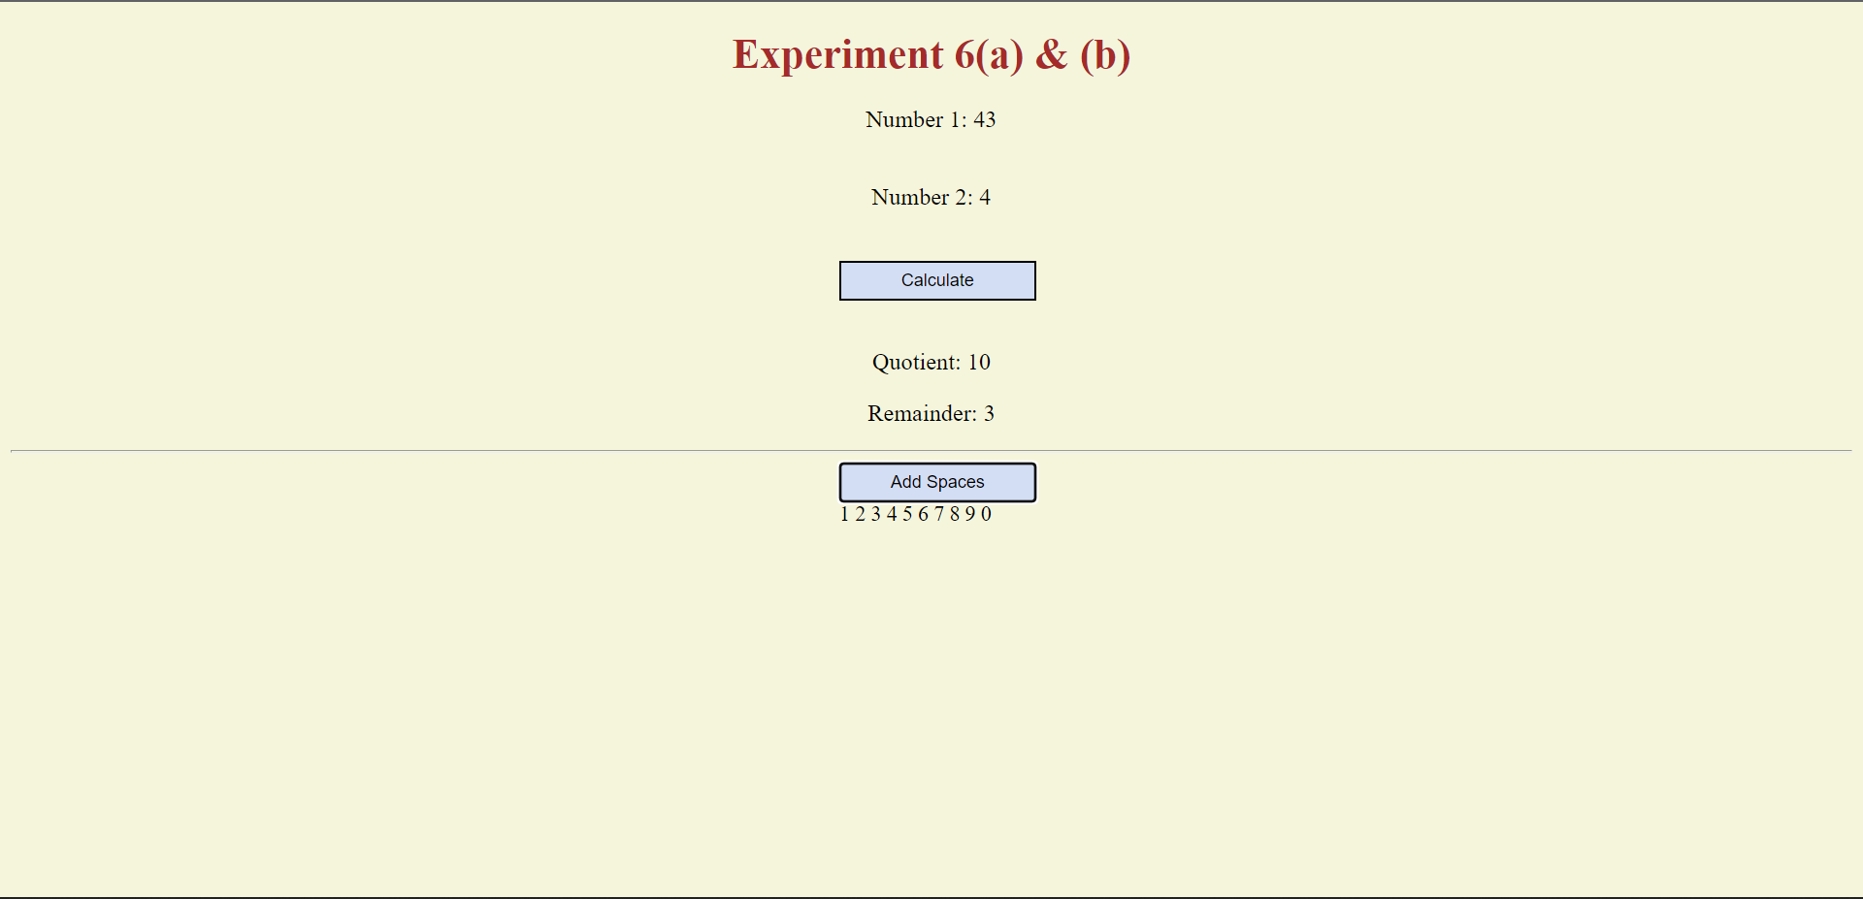

<!-- Create a college registration form to obtain a users first name, last name, mobile number, email address, submit and cancel button. Now validate the mobile number and email using java

script. -->

<!DOCTYPE html>

<html lang="en">

<head>

    <meta charset="UTF-8">

    <meta http-equiv="X-UA-Compatible" content="IE=edge">

    <meta name="viewport" content="width=device-width, initial-scale=1.0">

    <title>Form</title>

</head>

<body style="font-style:italic ; color: #ff4d4d;">

    <p style="font-size:100px; text-align:center; color :red;background-color: #c5d5c5;">

        College Registration form </p>

    <fieldset>

        <legend style="color: #c83349; font-size: x-large;">Personal-Info</legend>

        <form style="font-size:xx-large ; background-color: #bfff00;" name="Mform" onsubmit="return validationform()">

            <center><label for="fname">First Name</label><br>

                <input type="text" name="fname" id="fname"><br>

                <label for="lname">Last Name:</label><br>

                <input type="text" name="lname" id="lname"><br>

                <label for="Mobile_Number">Mobile_Number</label><br>

                <input type="text" name="Mobile_Number" id="Mobile_Number"><br>

                <label for="Email_Address">Email_Address:</label><br>

                <input type="text" name="Email_Address" id="Email_Address"><br>

                <input type="submit" value="Submit" onclick="return validate()">

            </center>

            <script>

*function* validationform() {

*const* fname = document.Mform.fname.value;

*const* lname = document.Mform.lname.value;

*const* Mobile_Number = document.Mform.Mobile_Number.value;

*const* Email_Address = document.Mform.Email_Address.value;

                    if (fname == null || fname == "") {

                        alert("First Name can't be blank");

                        return false;

                    } else if (lname == null || lname == "") {

                        alert("Last Name can't be blank");

                        return false;

                    } else if (Mobile_Number == null || Mobile_Number == "") {

                        alert("Mobile Number can't be blank");

                        return false;

                    } else if (Email_Address == null || Email_Address == "") {

                        alert("Email_Address can't be blank");

                        return false;

                    }

                }

            </script>

        </form>

    </fieldset>

</body>

</html>

Output-

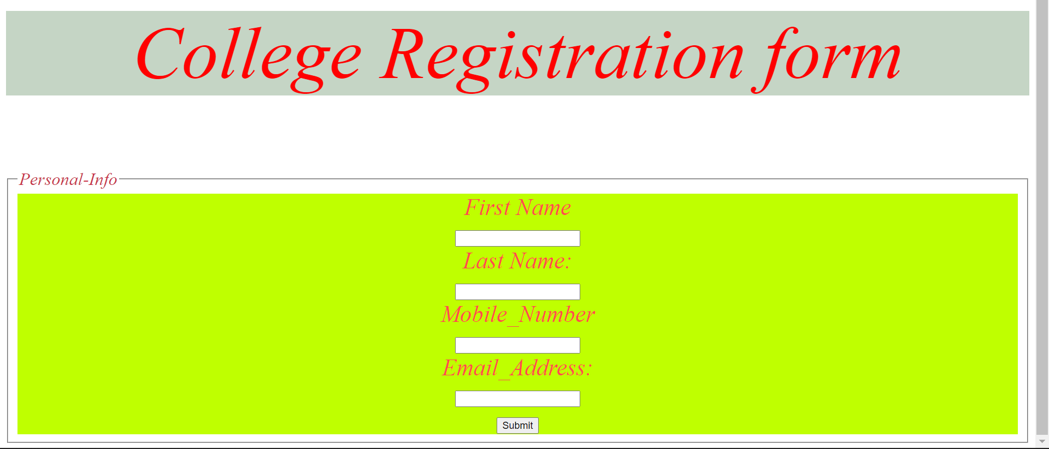

<!-- EXP-6-C -->

<!DOCTYPE html>

<html lang="en">

<head>

    <style>

        body {

*background-color*: rgb(9, 9, 28);

*color*: aqua;

*text-align*: center;

*font-size*: 30px;

*font-family*: cursive;

        }

        .calculator {

*width*: 350px;

*height*: 320px;

*background-color*: #c0c0c0;

*box-shadow*: 0px 0px 0px 10px #666;

*border*: 5px solid black;

*border-radius*: 10px;

        }

        #display {

*width*: 320px;

*height*: 40px;

*text-align*: right;

*background-color*: black;

*border*: 3px solid rgb(97, 155, 62);

*font-size*: 18px;

*left*: 2px;

*top*: 2px;

*color*: #7fff00;

        }

        .btnTop {

*color*: rgb(42, 185, 121);

*background-color*: #6f6f6f;

*font-size*: 14px;

*margin*: auto;

*width*: 50px;

*height*: 25px;

        }

        .btnNum {

*color*: white;

*background-color*: rgb(161, 27, 27);

*font-size*: 14px;

*margin*: auto;

*width*: 50px;

*height*: 25px;

        }

        .btnMath {

*color*: white;

*background-color*: #ff4561;

*font-size*: 14px;

*margin*: auto;

*width*: 50px;

*height*: 25px;

        }

        .btnOpps {

*color*: white;

*background-color*: #ff9933;

*font-size*: 14px;

*margin*: auto;

*width*: 50px;

*height*: 25px;

        }

    </style>

    <title>Document</title>

</head>

<body class="body">

    <strong>

        <center>

            <h1><u>SCIENTIFIC CALCULATOR </h1>

        </center></u>

    </strong>

    <head>

        <script language="javascript"></script>

    </head>

    <form name="sci-calc">

        <table class="calculator" cellspacing="0" cellpadding="1">

            <tr>

                <td colspan="5"><input id="display" name="display" value="0" size="28" maxlength="25"></td>

            </tr>

            <tr>

                <td><input type="button" class="btnTop" name="btnTop" value="C" onclick="this.form.display.value=  0 ">

                </td>

                <td><input type="button" class="btnTop" name="btnTop" value="<--"

                    onclick="deleteChar(this.form.display)"></td>

                    <td><input type="button" class="btnTop" name="btnTop" value="="

                        onclick="if(checkNum(this.form.display.value)) { compute(this.form) }"></td>

                        <td><input type="button" class="btnOpps" name="btnOpps" value="&#960;"

                            onclick="addChar(this.form.display,'3.14159265359')"></td>

                            <td><input type="button" class="btnMath" name="btnMath" value="%" onclick=" percent(this.form.display)">

                </td>

            </tr>

            <tr>

                <td><input type="button" class="btnNum" name="btnNum" value="7"

                    onclick="addChar(this.form.display, '7')"></td>

                    <td><input type="button" class="btnNum" name="btnNum" value="8"

                        onclick="addChar(this.form.display, '8')"></td>

                        <td><input type="button" class="btnNum" name="btnNum" value="9"

                            onclick="addChar(this.form.display, '9')"></td>

                            <td><input type="button" class="btnOpps" name="btnOpps" value="x&#94;"

                                onclick="if(checkNum(this.form.display.value)) { exp(this.form) }"></td>

                                <td><input type="button" class="btnMath" name="btnMath" value="/"

                        onclick="addChar(this.form.display, '/')"></td>

            <tr>

                <td><input type="button" class="btnNum" name="btnNum" value="4"

                    onclick="addChar(this.form.display, '4')"></td>

                    <td><input type="button" class="btnNum" name="btnNum" value="5"

                        onclick="addChar(this.form.display, '5')"></td>

                        <td><input type="button" class="btnNum" name="btnNum" value="6"

                            onclick="addChar(this.form.display, '6')"></td>

                            <td><input type="button" class="btnOpps" name="btnOpps" value="ln"

                                onclick="if(checkNum(this.form.display.value)) { ln(this.form) }"></td>

                                <td><input type="button" class="btnMath" name="btnMath" value="*"

                                    onclick="addChar(this.form.display, '*')"></td>

                                </tr>

            <tr>

                <td><input type="button" class="btnNum" name="btnNum" value="1"

                    onclick="addChar(this.form.display, '1')"></td>

                    <td><input type="button" class="btnNum" name="btnNum" value="2"

                        onclick="addChar(this.form.display, '2')"></td>

                        <td><input type="button" class="btnNum" name="btnNum" value="3"

                            onclick="addChar(this.form.display, '3')"></td>

                            <td><input type="button" class="btnOpps" name="btnOpps" value="&radic;"

                                onclick="if(checkNum(this.form.display.value)) { sqrt(this.form) }"></td>

                                <td><input type="button" class="btnMath" name="btnMath" value="-"

                                    onclick="addChar(this.form.display, '-')"></td>

                                </tr>

            <tr>

                <td><input type="button" class="btnMath" name="btnMath" value="&#177"

                    onclick="changeSign(this.form.display)"></td>

                    <td><input type="button" class="btnNum" name="btnNum" value="0"

                        onclick="addChar(this.form.display, '0')"></td>

                <td><input type="button" class="btnMath" name="btnMath" value="&#46;"

                    onclick="addChar(this.form.display, '&#46;')"></td>

                    <td><input type="button" class="btnOpps" name="btnOpps" value="x&#50;"

                        onclick="if(checkNum(this.form.display.value)) { square(this.form) }"></td>

                        <td><input type="button" class="btnMath" name="btnMath" value="+"

                            onclick="addChar(this.form.display, '+')"></td>

                        </tr>

            <tr>

                <td><input type="button" class="btnMath" name="btnMath" value="("

                    onclick="addChar(this.form.display, '(')"></td>

                    <td><input type="button" class="btnMath" name="btnMath" value=")"

                        onclick="addChar(this.form.display,')')"></td>

                <td><input type="button" class="btnMath" name="btnMath" value="cos"

                        onclick="if(checkNum(this.form.display.value)) { cos(this.form) }"></td>

                        <td><input type="button" class="btnMath" name="btnMath" value="sin"

                            onclick="if(checkNum(this.form.display.value)) { sin(this.form) }"></td>

                            <td><input type="button" class="btnMath" name="btnMath" value="tan"

                                onclick="if(checkNum(this.form.display.value)) { tan(this.form) }"></td>

                            </tr>

            </tabel>

    </form>

    <script>

*function* addChar(*input*, *character*) {

            if (*input*.value == null || *input*.value == "0")

*input*.value = *character*

            else

*input*.value += *character*

        }

*function* cos(*form*) {

*form*.display.value = Math.cos(*form*.display.value);

        }

*function* sin(*form*) {

*form*.display.value = Math.sin(*form*.display.value);

        }

*function* tan(*form*) {

*form*.display.value = Math.tan(*form*.display.value);

        }

*function* sqrt(*form*) {

*form*.display.value = Math.sqrt(*form*.display.value);

        }

*function* ln(*form*) {

*form*.display.value = Math.log(*form*.display.value);

        }

*function* exp(*form*) {

*form*.display.value = Math.exp(*form*.display.value);

        }

*function* deleteChar(*input*) {

*input*.value = *input*.value.substring(0, *input*.value.length - 1)

        }

*var* val = 0.0;

*function* percent(*input*) {

            val = *input*.value;

*input*.value = *input*.value + "%";

        }

*function* changeSign(*input*) {

            if (*input*.value.substring(0, 1) == "-")

*input*.value = *input*.value.substring(1, *input*.value.length)

            else

*input*.value = "-" + *input*.value

        }

*function* compute(*form*) {

*form*.display.value = eval(*form*.display.value);

        }

*function* square(*form*) {

*form*.display.value = eval(*form*.display.value) * eval(*form*.display.value)

        }

*function* checkNum(*str*) {

            for (*var* i = 0; i < *str*.length; i++) {

*var* ch = *str*.charAt(i);

                if (ch < "0" || ch > "9") {

                    if (ch != "/" && ch != "*" && ch != "+" && ch != "-" && ch != "."

                        && ch != "(" && ch != ")" && ch != "%") {

                        alert("invalid entry!")

                        return false

                    }

                }

            }

            return true

        }

    </script>

</body>

</html>

Output-

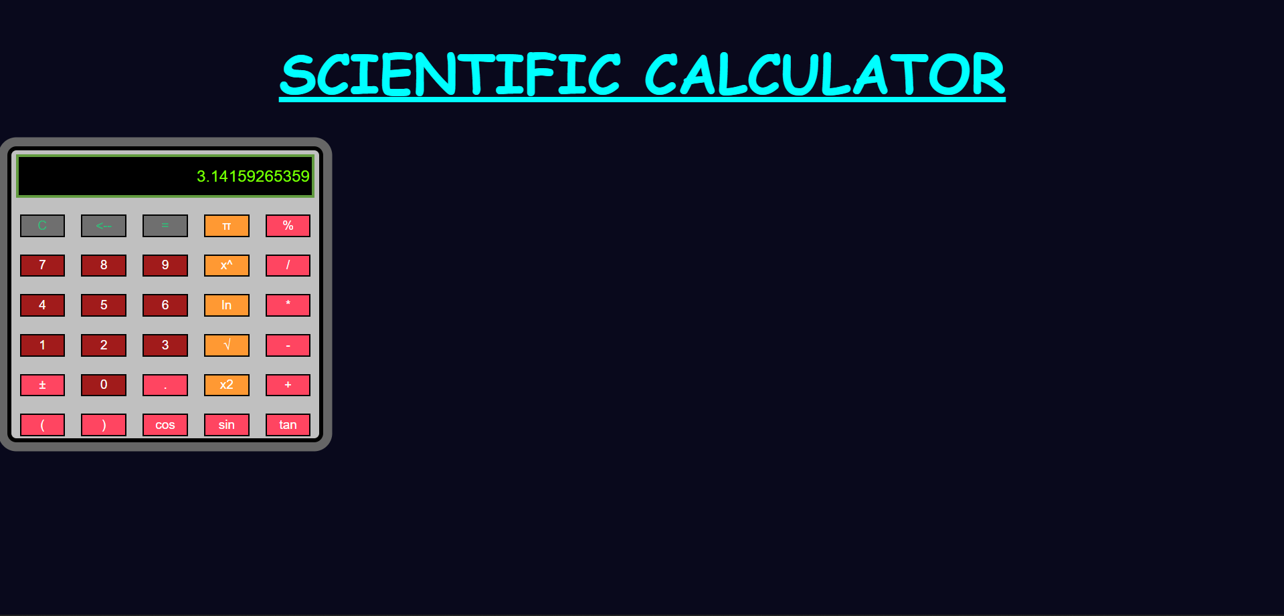

<!DOCTYPE html>

<html lang="en">

<head>

    <meta charset="UTF-8">

    <meta http-equiv="X-UA-Compatible" content="IE=edge">

    <meta name="viewport" content="width=device-width, initial-scale=1.0">

    <title>toss coin</title>

    <style>

        .border {

*border-radius*: 5px;

*border-width*: 10px;

*border-style*: solid;

*border-color*: black;

*background-color*: aquamarine;

        }

        .border2 {

*border-width*: 4px;

*border-style*: solid;

*border-color*: black;

*display*: inline-block;

*margin-left*: auto;

*padding*: 20px;

*background-color*: rgb(181, 250, 227);

        }

        .big {

*font-size*: larger;

        }

        td {

*padding*: 20px;

*background-color*: rgba(137, 43, 226, 0.341);

        }

        th {

*padding*: 20px;

*background-color*: rgba(137, 43, 226, 0.615);

        }

        .inline {

*padding-top*: 290px;

*padding-bottom*: 25px;

*padding-left*: 50px;

*padding-right*: 50px;

*display*: inline;

*background-color*: rgb(178, 255, 145);

        }

        img{

*width*: 270px;

        }

    </style>

</head>

<body style="background-color: rgba(144, 226, 231, 0.616);">

    <div class="border">

        <center>

            <h1 class="border2">Program to Toss a coin and count its frequency</h1>

        </center>

        <br>

        <center>

            <div class="inline" id="head">

                <img src="head.jpg" alt="head">

            </div>

            <div class="inline" id="tail">

                <img src="tail.jpg" alt="tail">

            </div>

            <br>

            <br><br>

            <button class="big" onclick="toss()">Toss Coin</button>

            <br>

            <br>

        </center>

    </div>

    <center>

        <table style="font-size: 40px; text-align: center; table-layout: fixed; width: 750px;">

            <tbody>

                <tr>

                    <th>Face</th>

                    <th>Frequency</th>

                    <th>Percentage</th>

                </tr>

                <tr>

                    <td>Head</td>

                    <td id="hf">0</td>

                    <td id="hp">0</td>

                </tr>

                <tr>

                    <td>Tail</td>

                    <td id="tf">0</td>

                    <td id="tp">0</td>

                </tr>

            </tbody>

        </table>

    </center>

    <script>

*var* y = 0, z = 0;

*function* toss() {

*let* x = Math.floor(Math.random() * 100 + 1);

            if (x % 2 == 0) {

                document.getElementById("hf").innerHTML++;

                y++;

*let* one = 100 * y / (y + z);

*let* two = 100 * z / (y + z);

                document.getElementById("head").style.backgroundColor = "Green";

                document.getElementById("tail").style.backgroundColor = "rgb(178, 255, 145)";

                document.getElementById("hp").innerHTML = one.toFixed(2);

                document.getElementById("tp").innerHTML = two.toFixed(2);

            }

            else {

                document.getElementById("tf").innerHTML++;

                z++;

*let* one = 100 * y / (y + z);

*let* two = 100 * z / (y + z);

                document.getElementById("tail").style.backgroundColor = "Green";

                document.getElementById("head").style.backgroundColor = "rgb(178, 255, 145)";

                document.getElementById("hp").innerHTML = one.toFixed(2);

                document.getElementById("tp").innerHTML = two.toFixed(2);

            }

        }

    </script>

</body>

</body>

</html>

Output-

